Supplemental material

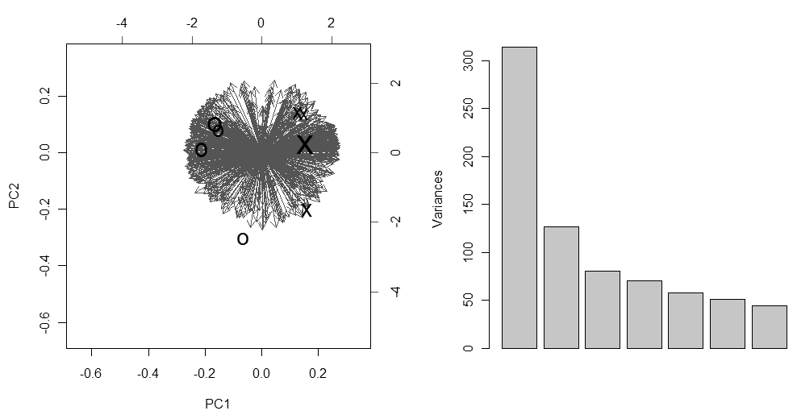
Figure A - Pseudo-3D biplot for the first three components of a PCA calculation with scale factor = 1/sd, where “sd” is the standard deviation of the variable; big font denotes a high PC3 value, small font denotes a low PC3 value (samples in black: O, control; X, handling; variables in grey), on the left. Plot showing explained variance for the first 7 components, on the right.

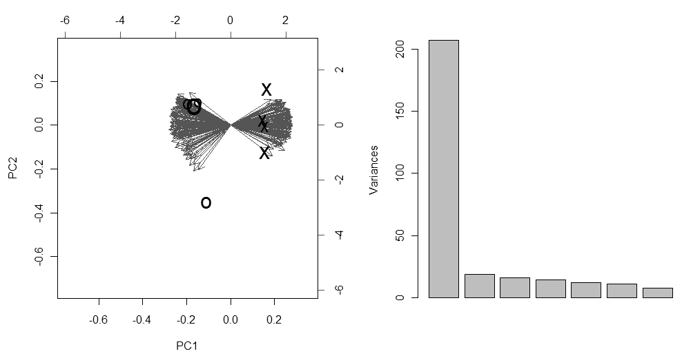
Figure B - Pseudo-3D biplot for the first three components of a PCA calculation with scale factor = 1/sd, where “sd” is the standard deviation of the variable, when reducing the analysis to the 287 spots deemed significant by univariate analysis; big font denotes a high PC3 value, small font denotes a low PC3 value (samples in black: O, control; X, handling; variables in grey), on the left. Plot showing explained variance for the first 7 components, on the right.
Figure C - Barplot showing the abundance levels of all identified proteins involved in stress response, protein synthesis, folding and turnover that displayed significantly different abundance between the CTRL and STR groups (Mann-Whitney, p < 0.05). Each bar represents the spot median abundance for the two groups (normalized spot volume, in ppm) ± median absolute deviation (mad). Four gels were run per condition.

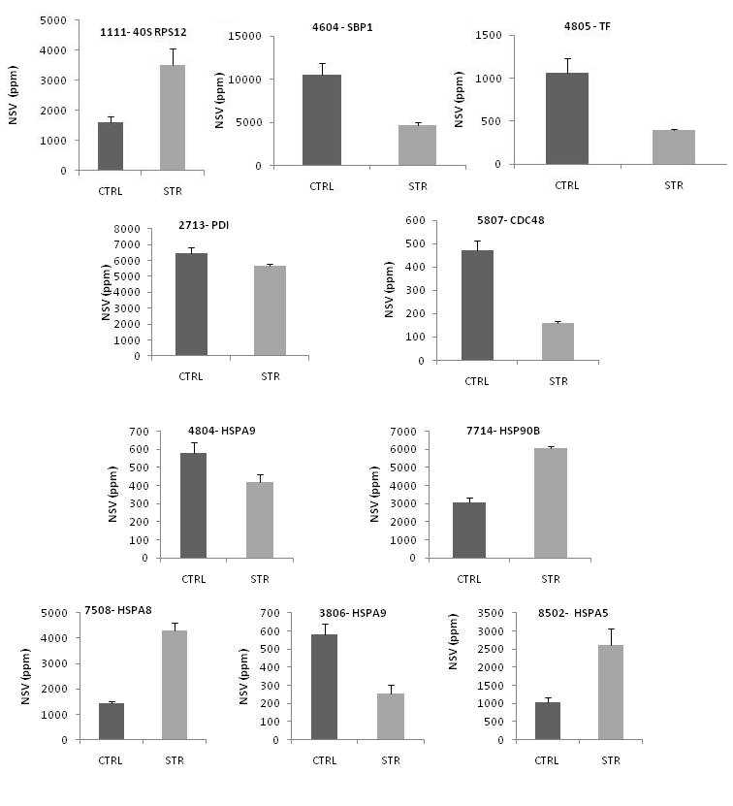

Figure D - Barplot showing the abundance levels of all identified proteins involved in (a) amino acid metabolism, urea cycle and methylation/folate pathways and (b) the cytoskeletal system that displayed significantly different abundance between the CTRL and STR groups (Mann-Whitney, p < 0.05). Each bar represents the spot median abundance for the two groups (normalized spot volume, in ppm) ± median absolute deviation (mad). Four gels were run per condition.
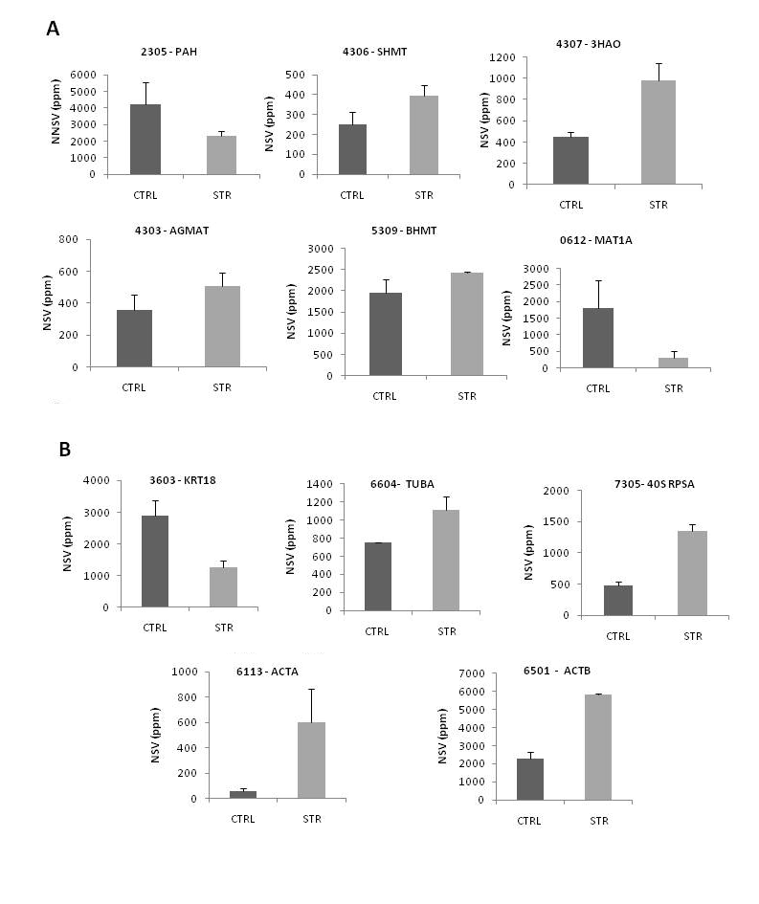

Figure E - Barplot showing the abundance levels of all identified proteins involved in carbohydrate metabolism and energy homeostasis that displayed significantly different abundance between the CTRL and STR groups (Mann-Whitney, p < 0.05). Each bar represents the spot median abundance for the two groups (normalized spot volume, in ppm) ± median absolute deviation (mad). Four gels were run per condition.

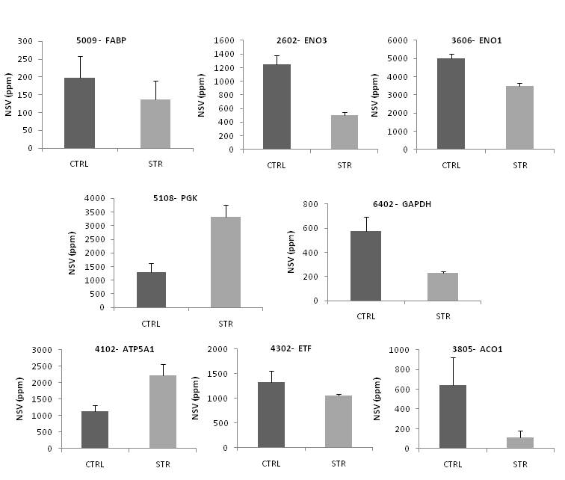

Figure F - Barplot showing the abundance levels of all identified proteins involved in (a) aldehyde detoxification, (b) steroid hormone metabolism, (c) purine salvage and (d) tissue injury and remodelling that displayed significantly different abundance between the CTRL and STR groups (Mann-Whitney, p < 0.05). Each bar represents the spot median abundance for the two groups (normalized spot volume, in ppm) ± median absolute deviation (mad). Four gels were run per condition.
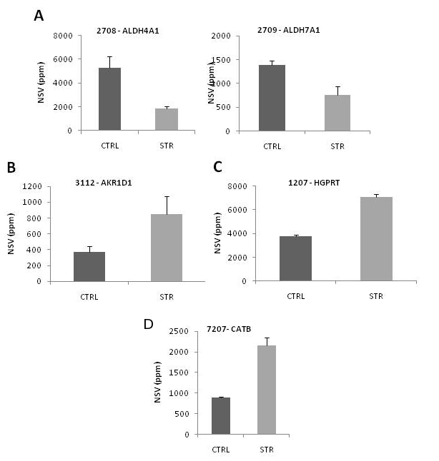

Figure G – Diagram showing the relationships between the urea cycle, the cytosolic and mitochondrial folate pools and the metabolism of polyamines, methionine, glycine, serine and betaine. Proteins which were seen to be upregulated/downregulated and metabolites which should have higher/lower steady-state levels are colour-coded (with green and red, respectively).

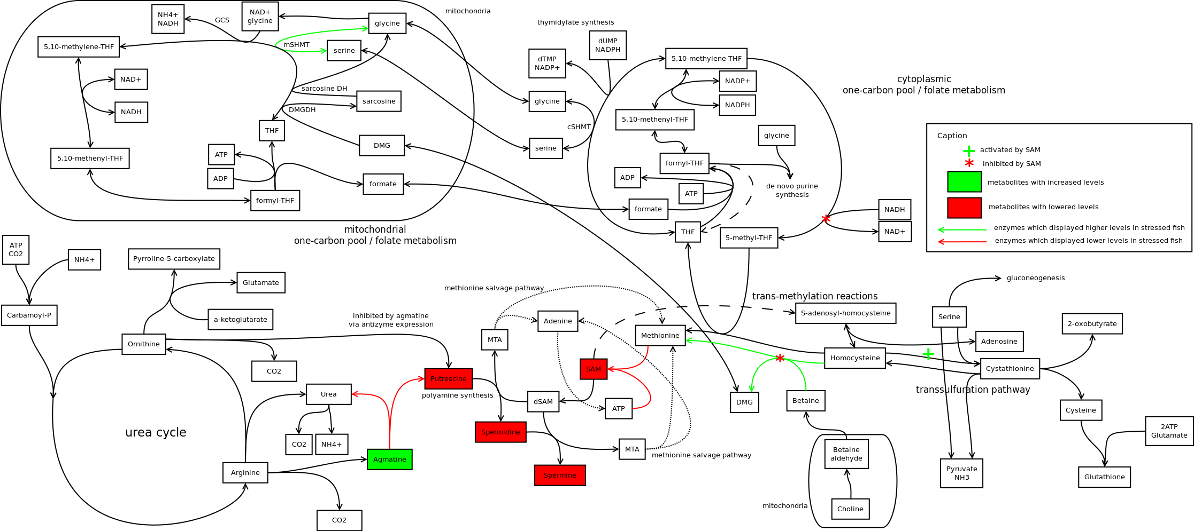

Table A - List of comparative studies mentioning any of the proteins identified in the study. Information regarding the up or down-regulation of each protein for each study is colour-coded with green and red, respectively. See attached .xls file

Calduch-Giner et al., 2010 [1]
Forné et al, 2009 [2]
Kling et al., 2009 [3]
Smith et al., 2009[4]
Costa et al., 2010[5]
Jury et al., 2008[6]
Salas-Leiton et al., 2009[7]
Ali et al., 2003[8]
Finne et al., 2007[9]
Hamza et al., 2010 [10]
Fukuhara et al., 2003[11]
Hudder et al., 2007[12]
Ibarz et al., 2010 [13]
Zamora et al., 2002[14]
Kassahn et al., 2007[15]
Kirpich et al., 2010 [16]
Bosutti et al., 2002[17]
Peatman et al., 2007[18]
Thorne et al., 2010[19]
Gracey et al., 2001[20]
Salem et al., 2007[21]
Veiseth-Kent et al., 2010 [22]
Valéry et al., 2001[23]
Yuan et al., 2007[24]
Yum et al., 2010 [25]
Rockett et al., 2001[26]
Hook et al., 2006[27]
Aluru et al., 2009 [28]
Becker et al., 2001[29]
Lam et al., 2006[30]
Alves et al., 2009 [31]
Li et al.,1996[32]
Chung et al., 2005[33]
Boswell et al., 2009 [34]
Miller et al., 1991[35]
Ewart et al., 2005[36]
Chen et al., 2009 [37]
Krasnov et al., 2005 (2)[38]
Ha et al., 2003[39]
Huang et al., 2009 [40]
Krasnov et al., 2005[41]
Osuna-Jimenez et al., 2009[42]
Sehata et al., 2005[45]
Talbot et al., 2009[43]
Yamamoto et al., 2005[44]
Malécot et al., 2009[45]
Kiyosawa et al., 2004[46]
Banerjee et al., 2008[47]
Prentice et al., 2004[48]
Inadera et al., 2008[49]
Mezhoud et al., 2008[50]
Peatman et al., 2008[51]
Wulff et al., 2008 (2)[52]
Wulff et al., 2008[53]
Drew et al., 2008[54]

Sources for the table

[1] Calduch-Giner JA, Davey G, Saera-Vila A, Houeix B, Talbot A, Prunet P, Cairns MT, Perez-Sanchez J. Use of microarray technology to assess the time course of liver stress response after confinement exposure in gilthead sea bream (Sparus aurata L.). BMC Genomics 2010;11: 193.
[2] Forne I, Agulleiro MJ, Asensio E, Abian J, Cerda J. 2-D DIGE analysis of Senegalese sole (Solea senegalensis) testis proteome in wild-caught and hormone-treated F1 fish. Proteomics 2009;9: 2171-81.
[3] Kling P, Forlin L. Proteomic studies in zebrafish liver cells exposed to the brominated flame retardants HBCD and TBBPA. Ecotoxicol Environ Saf 2009;72: 1985-93.
[4] Smith RW, Cash P, Ellefsen S, Nilsson GE. Proteomic changes in the crucian carp brain during exposure to anoxia. Proteomics 2009;9: 2217-29.
[5] Costa PM, Chicano-Galvez E, Lopez Barea J, DelValls TA, Costa MH. Alterations to proteome and tissue recovery responses in fish liver caused by a short-term combination treatment with cadmium and benzo[a]pyrene. Environ Pollut 2010;158: 3338-46.
[6] Jury DR, Kaveti S, Duan ZH, Willard B, Kinter M, Londraville R. Effects of calorie restriction on the zebrafish liver proteome. Comp Biochem Physiol Part D Genomics Proteomics 2008;3: 275-82.
[7] Salas-Leiton E, Canovas-Conesa B, Zerolo R, Lopez-Barea J, Canavate JP, Alhama J. Proteomics of juvenile senegal sole (Solea senegalensis) affected by gas bubble disease in hyperoxygenated ponds. Mar Biotechnol (NY) 2009;11: 473-87.
[8] Ali KS, Dorgai L, Abraham M, Hermesz E. Tissue- and stressor-specific differential expression of two hsc70 genes in carp. Biochemical and Biophysical Research Communications 2003;307: 503-9.
[9] Finne EF, Cooper GA, Koop BF, Hylland K, Tollefsen KE. Toxicogenomic responses in rainbow trout (Oncorhynchus mykiss) hepatocytes exposed to model chemicals and a synthetic mixture. Aquat Toxicol 2007;81: 293-303.
[10] Hamza VZ, Kumar PR, Jeevanram RK, Santanam R, Danalaksmi B, Mohankumar MN. A simple method to irradiate blood cells in vitro with radon gas. Radiat Prot Dosimetry 2008;130: 343-50.
[11] Fukuhara Y, Hirasawa A, Li XK, Kawasaki M, Fujino M, Funeshima N, Katsuma S, Shiojima S, Yamada M, Okuyama T, Suzuki S, Tsujimoto G. Gene expression profile in the regenerating rat liver after partial hepatectomy. J Hepatol 2003;38: 784-92.
[12] Hudder A, Song W, O'Shea KE, Walsh PJ. Toxicogenomic evaluation of microcystin-LR treated with ultrasonic irradiation. Toxicol Appl Pharmacol 2007;220: 357-64.
[13] Ibarz A, Martin-Perez M, Blasco J, Bellido D, de Oliveira E, Fernandez-Borras J. Gilthead sea bream liver proteome altered at low temperatures by oxidative stress. Proteomics 2010;10: 963-75.
[14] Zamora R, Vodovotz Y, Aulak KS, Kim PK, Kane JM, 3rd, Alarcon L, Stuehr DJ, Billiar TR. A DNA microarray study of nitric oxide-induced genes in mouse hepatocytes: implications for hepatic heme oxygenase-1 expression in ischemia/reperfusion. Nitric Oxide 2002;7: 165-86.
[15] Kassahn KS, Crozier RH, Ward AC, Stone G, Caley MJ. From transcriptome to biological function: environmental stress in an ectothermic vertebrate, the coral reef fish Pomacentrus moluccensis. BMC Genomics 2007;8: 358.
[16] Kirpich IA, Gobejishvili LN, Bon Homme M, Waigel S, Cave M, Arteel G, Barve SS, McClain CJ, Deaciuc IV. Integrated hepatic transcriptome and proteome analysis of mice with high-fat diet-induced nonalcoholic fatty liver disease. J Nutr Biochem 2011;22: 38-45.
[17] Bosutti A, Toigo G, Ciocchi B, Situlin R, Guarnieri G, Biolo G. Regulation of muscle cathepsin B proteolytic activity in protein-depleted patients with chronic diseases. Clin Nutr 2002;21: 373-8.
[18] Peatman E, Baoprasertkul P, Terhune J, Xu P, Nandi S, Kucuktas H, Li P, Wang S, Somridhivej B, Dunham R, Liu Z. Expression analysis of the acute phase response in channel catfish (Ictalurus punctatus) after infection with a Gram-negative bacterium. Dev Comp Immunol 2007;31: 1183-96.
[19] Thorne MAS, Burns G, Fraser KPP, Hillyard G, Clark MS. Transcription profiling of acute temperature stress in the Antarctic plunderfish Harpagifer antarcticus. Marine Genomics 2010;3: 35-44.
[20] Gracey AY, Troll JV, Somero GN. Hypoxia-induced gene expression profiling in the euryoxic fish Gillichthys mirabilis. Proc Natl Acad Sci U S A 2001;98: 1993-8.
[21] Salem M, Silverstein J, Rexroad CE, 3rd, Yao J. Effect of starvation on global gene expression and proteolysis in rainbow trout (Oncorhynchus mykiss). BMC Genomics 2007;8: 328.
[22] Veiseth-Kent E, Grove H, Faergestad EM, Fjaera SO. Changes in muscle and blood plasma proteomes of Atlantic salmon (Salmo salar) induced by crowding. Aquaculture 2010;309: 272-9.
[23] Valery C, Grob JJ, Verrando P. Identification by cDNA microarray technology of genes modulated by artificial ultraviolet radiation in normal human melanocytes: relation to melanocarcinogenesis. J Invest Dermatol 2001;117: 1471-82.
[24] Yuan X, Kuramitsu Y, Furumoto H, Zhang X, Hayashi E, Fujimoto M, Nakamura K. Nuclear protein profiling of Jurkat cells during heat stress-induced apoptosis by 2-DE and MS/MS. Electrophoresis 2007;28: 2018-26.
[25] Yum S, Woo S, Kagami Y, Park HS, Ryu JC. Changes in gene expression profile of medaka with acute toxicity of Arochlor 1260, a polychlorinated biphenyl mixture. Comp Biochem Physiol C Toxicol Pharmacol 2010;151: 51-6.
[26] Rockett JC, Mapp FL, Garges JB, Luft JC, Mori C, Dix DJ. Effects of hyperthermia on spermatogenesis, apoptosis, gene expression, and fertility in adult male mice. Biol Reprod 2001;65: 229-39.
[27] Hook SE, Skillman AD, Small JA, Schultz IR. Gene expression patterns in rainbow trout, Oncorhynchus mykiss, exposed to a suite of model toxicants. Aquat Toxicol 2006;77: 372-85.
[28] Aluru N, Vijayan MM. Stress transcriptomics in fish: a role for genomic cortisol signaling. Gen Comp Endocrinol 2009;164: 142-50.
[29] Becker B, Vogt T, Landthaler M, Stolz W. Detection of differentially regulated genes in keratinocytes by cDNA array hybridization: Hsp27 and other novel players in response to artificial ultraviolet radiation. J Invest Dermatol 2001;116: 983-8.
[30] Lam SH, Winata CL, Tong Y, Korzh S, Lim WS, Korzh V, Spitsbergen J, Mathavan S, Miller LD, Liu ET, Gong Z. Transcriptome kinetics of arsenic-induced adaptive response in zebrafish liver. Physiol Genomics 2006;27: 351-61.
[31] Alves RN, Cordeiro O, Silva TS, Richard N, de Vareilles M, Marino G, Di Marco P, Rodrigues PM, Conceicao LEC. Metabolic molecular indicators of chronic stress in gilthead seabream (Sparus aurata) using comparative proteomics. Aquaculture 2010;299: 57-66.
[32] Li H, Ko HP, Whitlock JP. Induction of phosphoglycerate kinase 1 gene expression by hypoxia - Roles of Arnt and HIF1 alpha. Journal of Biological Chemistry 1996;271: 21262-7.
[33] Chung H, Hong DP, Jung JY, Kim HJ, Jang KS, Sheen YY, Ahn JI, Lee YS, Kong G. Comprehensive analysis of differential gene expression profiles on carbon tetrachloride-induced rat liver injury and regeneration. Toxicol Appl Pharmacol 2005;206: 27-42.
[34] Boswell MG, Wells MC, Kirk LM, Ju Z, Zhang Z, Booth RE, Walter RB. Comparison of gene expression responses to hypoxia in viviparous (Xiphophorus) and oviparous (Oryzias) fishes using a medaka microarray. Comp Biochem Physiol C Toxicol Pharmacol 2009;149: 258-65.
[35] Miller EK, Raese JD, Morrisonbogorad M. Expression of Heat-Shock Protein-70 and Heat-Shock Cognate-70 Messenger-Rnas in Rat Cortex and Cerebellum after Heat-Shock or Amphetamine Treatment. Journal of Neurochemistry 1991;56: 2060-71.
[36] Ewart KV, Belanger JC, Williams J, Karakach T, Penny S, Tsoi SC, Richards RC, Douglas SE. Identification of genes differentially expressed in Atlantic salmon (Salmo salar) in response to infection by Aeromonas salmonicida using cDNA microarray technology. Dev Comp Immunol 2005;29: 333-47.
[37] Chen M, Wang Y, Zhao Y, Wang L, Gong J, Wu L, Gao X, Yang Z, Qian L. Dynamic proteomic and metabonomic analysis reveal dysfunction and subclinical injury in rat liver during restraint stress. Biochim Biophys Acta 2009;1794: 1751-65.
[38] Krasnov A, Koskinen H, Pehkonen P, Rexroad CE, 3rd, Afanasyev S, Molsa H. Gene expression in the brain and kidney of rainbow trout in response to handling stress. BMC Genomics 2005;6: 3.
[39] Ha HY, Kim KS, Yeom YI, Lee JK, Han PL. Chronic restraint stress massively alters the expression of genes important for lipid metabolism and detoxification in liver. Toxicol Lett 2003;146: 49-63.
[40] Huang TS, Olsvik PA, Krovel A, Tung HS, Torstensen BE. Stress-induced expression of protein disulfide isomerase associated 3 (PDIA3) in Atlantic salmon (Salmo salar L.). Comp Biochem Physiol B Biochem Mol Biol 2009;154: 435-42.
[41] Krasnov A, Koskinen H, Rexroad C, Afanasyev S, Molsa H, Oikari A. Transcriptome responses to carbon tetrachloride and pyrene in the kidney and liver of juvenile rainbow trout (Oncorhynchus mykiss). Aquat Toxicol 2005;74: 70-81.
[42] Osuna-Jimenez I, Williams TD, Prieto-Alamo MJ, Abril N, Chipman JK, Pueyo C. Immune- and stress-related transcriptomic responses of Solea senegalensis stimulated with lipopolysaccharide and copper sulphate using heterologous cDNA microarrays. Fish Shellfish Immunol 2009;26: 699-706.
[43] Talbot AT, Pottinger TG, Smith TJ, Cairns MT. Acute phase gene expression in rainbow trout (Oncorhynchus mykiss) after exposure to a confinement stressor: A comparison of pooled and individual data. Fish Shellfish Immunol 2009;27: 309-17.
[44] Yamamoto T, Kikkawa R, Yamada H, Horii I. Identification of oxidative stress-related proteins for predictive screening of hepatotoxicity using a proteomic approach. J Toxicol Sci 2005;30: 213-27.
[45] Malecot M, Mezhoud K, Marie A, Praseuth D, Puiseux-Dao S, Edery M. Proteomic study of the effects of microcystin-LR on organelle and membrane proteins in medaka fish liver. Aquatic Toxicology 2009;94: 153-61.
[46] Kiyosawa N, Ito K, Sakuma K, Niino N, Kanbori M, Yamoto T, Manabe S, Matsunuma N. Evaluation of glutathione deficiency in rat livers by microarray analysis. Biochem Pharmacol 2004;68: 1465-75.
[47] Banerjee A, Russell WK, Jayaraman A, Ramaiah SK. Identification of proteins to predict the molecular basis for the observed gender susceptibility in a rat model of alcoholic steatohepatitis by 2-D gel proteomics. Proteomics 2008;8: 4327-37.
[48] Prentice HM, Milton SL, Scheurle D, Lutz PL. The upregulation of cognate and inducible heat shock proteins in the anoxic turtle brain. Journal of Cerebral Blood Flow and Metabolism 2004;24: 826-8.
[49] Inadera H, Tachibana S, Takasaki I, Tabuchi Y, Matsushima K, Uchida M, Shimomura A. Expression profile of liver genes in response to hepatotoxicants identified using a SAGE-based customized DNA microarray system. Toxicol Lett 2008;177: 20-30.
[50] Mezhoud K, Praseuth D, Puiseux-Dao S, Francois JC, Bernard C, Edery M. Global quantitative analysis of protein expression and phosphorylation status in the liver of the medaka fish (Oryzias latipes) exposed to microcystin-LR I. Balneation study. Aquat Toxicol 2008;86: 166-75.
[51] Peatman E, Terhune J, Baoprasertkul P, Xu P, Nandi S, Wang S, Somridhivej B, Kucuktas H, Li P, Dunham R, Liu Z. Microarray analysis of gene expression in the blue catfish liver reveals early activation of the MHC class I pathway after infection with Edwardsiella ictaluri. Mol Immunol 2008;45: 553-66.
[52] Wulff T, Hoffmann EK, Roepstorff P, Jessen F. Comparison of two anoxia models in rainbow trout cells by a 2-DE and MS/MS-based proteome approach. Proteomics 2008;8: 2035-44.
[53] Wulff T, Jessen F, Roepstorff P, Hoffmann EK. Long term anoxia in rainbow trout investigated by 2-DE and MS/MS. Proteomics 2008;8: 1009-18.
[54] Drew RE, Rodnick KJ, Settles M, Wacyk J, Churchill E, Powell MS, Hardy RW, Murdoch GK, Hill RA, Robison BD. Effect of starvation on transcriptomes of brain and liver in adult female zebrafish (Danio rerio). Physiological Genomics 2008;35: 283-95.

