Vol 79, No 4 (2015) > Gamaza
Testing Nordmøre grids on the target and by-catch species of the commercial bottom trawl fishery in the Gulf of Cadiz
MariÁngeles Gamaza ¹, Ignacio Sobrino ¹, Karim Erzini ²
¹ IEO, Instituto Español de Oceanografía, Puerto pesquero, muelle de Levante s/n, 11006, Cádiz, Spain.
E-mail: mari.gamaza@gmail.com
² Centre of Marine Sciences (CCMAR), University of Algarve, Campus de Gambelas, 8005-139 Faro, Portugal.
Summary: Sorting grids have been tested worldwide in trawl fisheries. Here we report upon the first trials performed using Nordmøre sorting grids with four different bar spacings in the trawl fisheries of the Gulf of Cadiz targeting crustaceans as the main resource. A total of 288 valid hauls and 67 commercial species were caught. Escapement and escape size selectivity were evaluated for the most important target and by-catch species. A decrease in the percentage of biomass escape was recorded with increasing grid spacing for the two target species, deep-water rose shrimp (Parapenaeus longirostris) and Norway lobster (Nephrops norvegicus), from 24% to 8% for the former and from 86 to 9% for the latter, with a 15-mm and 30-mm grid respectively. In general, high escape rates were found for most finfish and cephalopods. For hake (Merluccius merluccius), as the main by-catch species, the results showed an escape rate decreasing from 96% to 71% as the bar spacing increased. Our findings suggest the 30-mm grid would be effective for the deep-water crustacean trawlers but different mitigation measures will be required for other métiers in the multispecies trawl fishery of the Gulf of Cadiz.
Keywords: by-catch; Gulf of Cadiz; deep-water rose shrimp; Nordmøre grids; selectivity; trawl fisheries.
Uso de rejillas separadoras Nordmøre sobre especies objetivo y accesorias de la flota de arrastre de fondo del Golfo de Cádiz
Resumen: Las rejillas o grillas separadoras han sido testadas en pesquerías de arrastre a nivel mundial. Aquí se exponen los resultados de los primeros ensayos usando rejillas separadoras tipo Nordmøre con cuatro espacios diferentes de separación entre barras para la flota de arrastre del Golfo de Cádiz que captura crustáceos como recurso principal. Se realizaron un total de 288 lances válidos y se capturaron unas 67 especies comerciales diferentes. El porcentaje de escape y la selectividad del escape por tallas fueron calculados para las especies comerciales y by-catch más importantes. Los resultados muestran un decrecimiento en el porcentaje de biomasa escapada al aumentar la separación entre barras para dos de las especies objetivos; gamba blanca (Parapenaeus longirostris) y cigala (Nephrops norvegicus), con porcentajes que oscilan desde 24 a 8% para la primera y 86 a 9% para la segunda, con las rejillas de 15 mm y 30 mm de separación entre barras respectivamente. En general, se obtienen altos porcentajes de escape para la mayoría de especies de peces y cefalópodos. Los resultados para merluza (Merluccius merluccius), como principal especie by-catch, muestran un decrecimiento en el porcentaje de escape desde 96% a 71% con el aumento de la separación entre barras respectivamente. Nuestros resultados sugieren que la rejilla de 30 mm de separación entre barras podría ser la más efectiva para la flota que dirige su captura a crustáceos en aguas profundas del Golfo de Cádiz pero diferentes medidas de mitigación serían necesarias para el resto de métiers de la pesquería de arrastre multiespecífica de esta zona.
Palabras clave: by-catch; Golfo de Cádiz; gamba blanca; rejilla Nordmøre; selectividad; pesquería de arrastre.
Citation/Como citar este artículo: Gamaza M.A., Sobrino I., Erzini K. 2015. Testing Nordmøre grids on the target and by-catch species of the commercial bottom trawl fishery in the Gulf of Cadiz. Sci. Mar. 79(4): 465-477. doi: http://dx.doi.org/10.3989/scimar.04180.15A
Editor: E. Massutí.
Received: November 17, 2014. Accepted: September 15, 2015. Published: October 16, 2015.
Copyright: © 2015 CSIC. This is an open-access article distributed under the Creative Commons Attribution-Non Commercial Lisence (by-nc) Spain 3.0.
CONTENTS
Summary
Resumen
Introduction
Methods
Results
Discussion
Acknowledgements
References
INTRODUCTIONTop
The Gulf of Cadiz is located in the southern part of ICES Division IXa (Fig. 1). This region is considered a zone of exception where a minimum diamond-mesh codend size of 55 mm is allowed for the trawl fleet, whereas in the northern part of ICES Division IXa (Portugal) the minimum codend mesh size for fish is 70 mm and 55-59 mm is only allowed for shrimps.
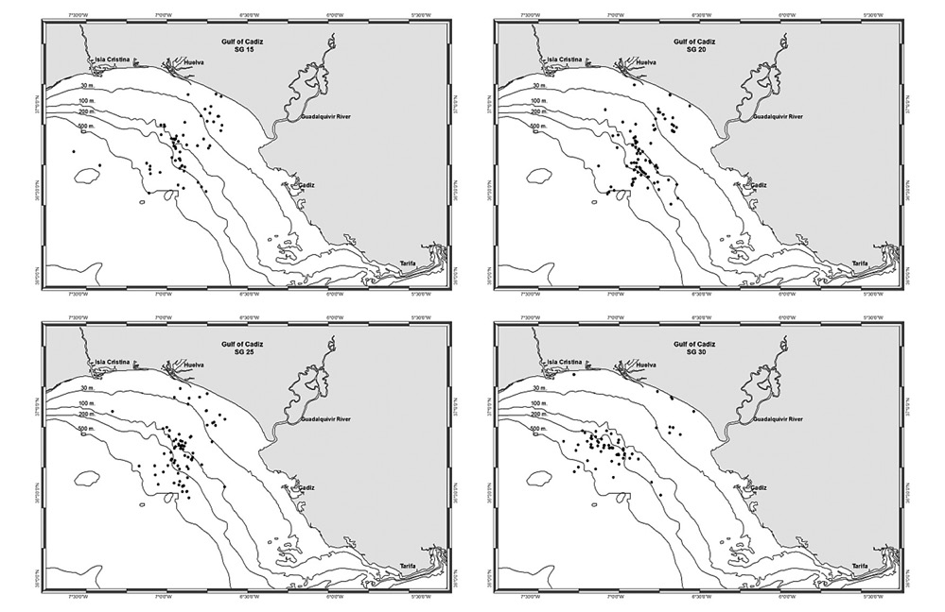 | Full size image

Fig. 1. – Spacial distribution of the sampling by sorting grid in the Gulf of Cadiz.
Historically, the multispecies bottom trawl fisheries located in the Gulf of Cadiz exert a high fishing pressure on a large number of species. The fleet is currently composed of 142 vessels licensed to operate in the Gulf of Cadiz. The mean characteristics of this fleet are 25 GTR, 215 HP and 13.9 m length, with average annual landings of around 12000 t.
The fishing grounds in the Gulf of Cadiz are characterized by a coastline of 300 km with a continental shelf more than 80 km wide. The western side of the platform is sandy and wider, becoming narrow and rocky near to the Strait of Gibraltar (Ramos et al. 1997). This different fishing grounds in which the trawling fleet operates, at depths of 20 to 600 m, is reflected in the heterogeneity of the catches, with more than 70 different species landed (Sobrino et al. 1996). The composition of the landings depends on the target species, vessel characteristics, the distance of fishing ground from the landing port, the season of the year and the fishing strategy of the skipper. In coastal grounds target species include flatfish such as wedge sole (Dicologlossa cuneata (Linnaeus, 1758)), sole (Solea spp, (Linnaeus, 1758)), spotted flounder (Citharus linguatula (Linnaeus, 1758)), cephalopods such as cuttlefish (Sepia officinalis (Linnaeus, 1758)), octopus (Octopus vulgaris (Cuvier, 1797)) and squid (Loligo vulgaris (Lamarck, 1798)), and crustaceans such as caramote prawn (Melicertus kerathurus (Forskal, 1771)).
At deeper grounds target species are deep-water rose shrimp ((P. longirostris (Lucas, 1846)), Norway lobster (Nephrops novergicus (Linnaeus, 1750)), horse mackerel (Trachurus trachurus (Linnaeus, 1758)), and blue whiting (Micromesistius potassou (Risso, 1827)). European hake (Merluccius merluccius (Linnaeus, 1758)) can be found at different depths depending on their growth and biological cycle, with smaller individuals found in shallower waters, whereas mature and larger hake inhabit greater depths (González et al. 1994).
In this scenario the local trawl fleet working in this area has changed its modus operandi over the years and is now composed of different métiers, with a division of the fleet by fishing grounds (Jiménez et al. 2004) and some of the vessels fishing solely for crustaceans, targeting deep-water rose shrimp and Norway lobster as the main resources. The deep-water rose shrimp fishery is the largest one in this area, with annual landings of 300 to 1000 t of this high-value target species (Sobrino et al. 1994, Sobrino and García 2007).
The poor selectivity resulting from the use of the current 55-mm diamond-mesh codend used for all depths and grounds contributes to catches consisting of a large number of species with no commercial value, and of commercial individuals smaller than the minimum legal size.
Much of this by-catch is not marketed or used and the unwanted animals are discarded and thrown back into the sea. The latest studies on trawl discards in the area show percentages ranging from 17% to 47% depending on the time of the year and depth range (Coll et al. 2014).
The demersal resources of the Gulf of Cadiz are considered to be overexploited, with depleted stocks and expansion of fishing activities towards deeper and more distant fishing grounds (Coll et al. 2014). The need for solutions and management measures, when landings are reaching their historical minimum, is highlighted by the concerns of the local fishing industry, skippers and vessel owners.
Some countries with similar multispecies trawl fisheries but exploiting shrimp or prawn resources have implemented selective devices in their trawl fleets, commonly referred to as by-catch reduction devices. Based on the behavioural differences between fish and crustacean species when encountering a sorting grid device (Isaksen 1990, Fonseca et al. 2005), these selective devices have proven successful at reducing unwanted by-catch without excessive loss of target species (Isaksen 1990, Isaksen et al. 1992, Broadhurst 2000, Ercoli et al. 2001).
The reformed EU Common Fisheries Policy (EU Regulation 1380/2013) considers the problem of discards a top priority, stipulating a progressive phasing out of discards (‘landing obligation’) of commercial species subject to quotas or minimum conservation reference sizes. Exceptions are allowed for species for which high survival after discarding has been proven.
Target species and species compositions of the catches in the Gulf of Cadiz trawl fishery vary considerably with depths, suggesting that different mitigation measures will be required in this multispecies trawl fishery for the different trawl métiers.
This study was undertaken to test the performance of the different sorting grids (with a bar spacing of 15, 20, 25 and 30 mm) under commercial conditions in the trawl fleet targeting crustaceans in the Gulf of Cadiz. In order to check whether their future use would be practical in the analysed fishery, two aspects were taking into account: the potential reduction of the by-catch and discarded species and the potential losses of the target crustacean species. Furthermore, the quality of the crustacean catches is considered as a key point for the acceptance of the device by the fishermen and its future use. Future introduction of mitigation measures for the vessels operating with this device will be recommended.
METHODSTop
The sorting grid tested in this study was made of stainless steel with an inclined rectangular (1480 mm high x 1050 mm wide) design originating from Norway (Valdermasen et al. 1993). Four different bar spacings (15, 20, 25 and 30 mm) were tested (Fig. 2).
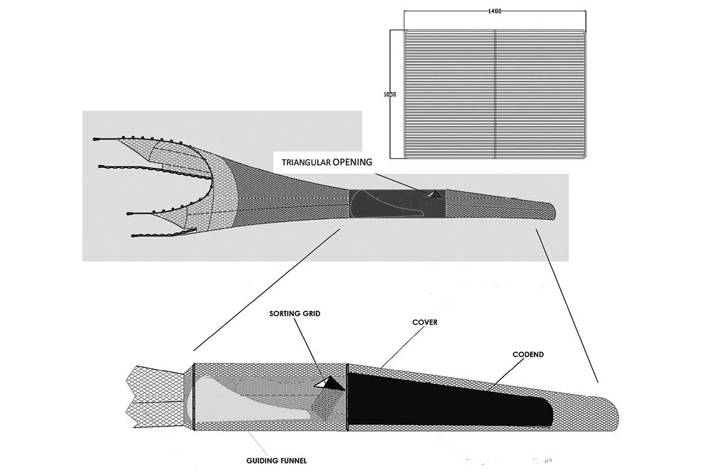 | Full size image

Fig. 2. – Technical drawing of the Nordmøre grid used in the experimental trials.
The rigging angle of the grid was set to 45°, since it has been demonstrated in previous studies that this is the best working angle for this design (Isaksen et al. 1992), and a guiding funnel was installed in front of the grid to avoid shrimp losses. When large individuals come into contact with the grid, they can escape through a triangular opening at the top of the codend. Smaller species and individuals can pass through the grid and enter the 20-mm mesh codend. Selectivity of sorting grids was assessed using a 20-mm mesh cover, following the specifications of Wileman et al. (1996), placed above the triangular opening to catch individuals that escaped through the triangular opening above the grid (Fig. 2).
The selectivity study was carried out from 15 July to 10 September 2008 (40 days at sea), on-board four chartered fishing vessels of similar technical characteristics (Table 1) operating their own commercial trawls and fishing according to normal commercial trawling practices. The trawl used by the vessels under study is constructed of polyamide netting with a 20-mm diamond-mesh codend. Each vessel used a sorting grid with one type of bar spacing (15, 20, 25 or 30 mm). Tows were carried out at depths ranging from 20 to 550 m, covering the bathymetric range of the deep-water rose shrimp (Sobrino 1998) in the Gulf of Cadiz area (Fig. 1). A total of 288 valid hauls were made under commercial towing conditions (Fig. 1, Table 2). Towing speeds varied between 2.5 and 3.5 knots, whereas tow duration ranged from 2 to more than 7 hours, depending on depth and area, with generally longer tows with increasing depth.
Table 1. – Mean characteristics of the vessels used in this study.
Vessel name | Grid (mm) | GRT | Length (m) | Hp
Nuevo capricho | 15 | 46.75 | 17.05 | 190
Juan Prim | 20 | 73.05 | 19.50 | 250
Nvo Carmen M. | 25 | 49.00 | 18.20 | 268
Isabel y Paco | 30 | 68.07 | 24.20 | 250
Table 2. – Number of valid hauls and weight percentage by grid (bar spacing) and bathymetric stratum.
 | Depth range (m)
 | 10-100 |  | 100-200 |  | 200-300 |  | 300-500 |  | Total
Bar spacing (mm) | hauls | weight % | hauls | weight % | hauls | weight % | hauls | weight % | hauls | weight %
15 | 24 | 12 | 16 | 16 | 8 | 35 | 12 | 22 | 60 | 18
20 | 43 | 50 | 29 | 31 | 4 | 27 | 14 | 26 | 90 | 32
25 | 27 | 36 | 23 | 34 | 7 | 29 | 18 | 29 | 75 | 33
30 | 11 | 2 | 23 | 19 | 13 | 9 | 16 | 23 | 63 | 17
Total | 105 | 100 | 91 | 100 | 32 | 100 | 60 | 100 | 288 | 100
The catches in the codend and cover of each haul were sorted by species, counted and weighed. For the most important commercial finfish species, total length (TL) was rounded down to the centimetre below. For commercial crustaceans, carapace length (CL) was rounded down to the millimetre below. For cephalopods, the mantle length (ML) was rounded down to the centimetre below. Sub-sampling of the rest of the by-catch species was carried out with TL rounded down to the centimetre below.
For the main commercial species, the cover and codend catches were analysed to assess the effectiveness of different grids. Target species considered were deep-water rose shrimp with a minimum landing size (MLS) of 22 mm CL, caramote prawn with no MLS in the area and Norway lobster with an MLS of 20 mm CL. Commercial by-catch species considered in this study include hake, with a 27-cm TL MLS, spotted flounder, cuttlefish and squid, the last three with no MLS in the Gulf of Cadiz.
Although the grids are designed to exclude by-catch fish species without losing much of the crustacean target species catch, they introduce size-selective effects on the target crustaceans. Therefore, the Kolmogorov-Smirnov (K-S) test was used to compare the size distributions of catches retained in the codend and the cover for the sorting grids with different bar spacings. The influence of depth and tow duration on escapement was evaluated by two-way ANOVA.
Size selectivity was modelled with three models: the generalized logistic model, the asymmetric Richards model and a model incorporating encounter probability. The generalized logistic model is
rl= e ( a+bl ) 1+ e ( a+bl ) | (1)
where rl is the probability that fish of length l will be retained in the cover (i.e. will escape through the triangular opening), and a and b are the parameters to estimate. Length at which the probability of being retained is 50% (L₅₀, length at first capture) and selection range (SR: L₇₅-L₂₅) were calculated from the expressions:
L 50 =− a b SR= L n (9) b | (2)
The Richards asymmetric model (Wileman et al. 1996) is
rl= ( e ( a+bl ) 1+ e ( a+bl ) ) 1/δ | (3)
where δ is the asymmetric parameter. If δ=1, it will be equivalent to the logistic model; if δ>1, the curve has a longer tail to the left; and if 0<δ<1, it has a longer tail to the right end.
To account for possible active avoidance behaviour of some fish and cephalopods, an encounter probability model (Tokai 1996) was also fitted:
rl= p* e ( a+bl ) [ 1+ e ( a+bl ) ]+[ 1−p ] | (4)
where p is the contact probability with the grids, and a and b are parameters of the logistic model.
The estimation of selectivity parameters a, b, δ and p was carried out by maximizing the log-likelihood using an ExcelTM Solver and a spreadsheet provided by Professor Tadashi Tokai (1997) of the University of Tokyo. The model with the lowest Akaike information criterion (Akaike 1974) was chosen as the one that best fitted the data.
RESULTSTop
Catch data
A total of 67 commercial species were caught (52 finfishes, 5 crustaceans and 10 cephalopods) (Table 3). The most important fish species was hake, which accounted for 28.2% of the total fish catch. The second most important was blue whiting, which accounted for 21.3%. Other important species were spotted flounder and Atlantic horse mackerel, which accounted for less than 10% each. For crustaceans, deep-water rose shrimp was the most important species caught, accounting for 80.1% of the crustacean catch in weight. Other important species were Norway lobster and prawn. Of the cephalopods, octopus, cuttlefish and squid accounted for 32.2%, 17.5% and 11.9% of the total cephalopod catch, respectively.
Table 3. – Total catches in weight (kg), number and weight percentage of commercial species of fishes, crustaceans and cephalopods during the survey.
FISHES | Weight | Number | % Weight
Merluccius merluccius | 4057 | 34161 | 28.19
Micromesistius poutassou | 3066 | 25926 | 21.31
Scomber scombrus | 1260 | 11055 | 8.76
Scomber japonicus | 1086 | 8237 | 7.55
Citharus linguatula | 1075 | 36453 | 7.47
Trachurus trachurus | 607 | 9795 | 4.22
Mullus surmuletus | 503 | 22339 | 3.50
Engraulis encrasicolus | 393 | 18578 | 2.74
Diplodus sargus sargus | 280 | 909 | 1.95
Trachurus mediterraneus | 271 | 3059 | 1.89
Pagellus erythrinus | 229 | 2770 | 1.59
Sardina pilchardus | 205 | 3729 | 1.43
Trachinus draco | 202 | 2807 | 1.41
Microchirus azevia | 105 | 1756 | 0.73
Lophius budegassa | 97 | 17 | 0.68
Trachurus picturatus | 91 | 523 | 0.63
Scyliorhinus canicula | 88 | 238 | 0.61
Dicologoglossa cuneata | 81 | 2287 | 0.56
Pagellus bellotii | 73 | 833 | 0.51
Balistes carolinensis | 69 | 84 | 0.48
Pagellus acarne | 53 | 572 | 0.37
Diplodus bellottii | 52 | 1000 | 0.36
Galeus melastomus | 49 | 103 | 0.34
Lithognathus mormyrus | 46 | 151 | 0.32
Sparus aurata | 46 | 74 | 0.32
Phycis blennoides | 41 | 173 | 0.28
Liza aurata | 30 | 81 | 0.21
Solea solea | 30 | 150 | 0.21
Cepola macrophthalma | 29 | 381 | 0.20
Diplodus annularis | 29 | 724 | 0.20
Solea senegalensis | 25 | 90 | 0.18
Pomadasys incisus | 23 | 155 | 0.16
Helicolenus dactylopterus | 19 | 75 | 0.13
Lophius piscatorius | 18 | 5 | 0.12
Centroscymnus coelolepis | 15 | 42 | 0.11
Dentex canariensis | 16 | 42 | 0.11
Spondyliosoma cantharus | 4 | 27 | 0.03
Synaptura lusitanica | 5 | 34 | 0.03
Argyrosomus regius | 3 | 21 | 0.02
Raja montagui | 3 | 2 | 0.02
Solea kleinii | 2 | 18 | 0.02
Brama brama | 1 | 1 | 0.01
Macroramphosus scolopax | 1 | 9 | 0.01
Pagellus bogaraveo | 2 | 12 | 0.01
Psetta maxima maxima | 1 | 2 | 0.01
Raja asterias | 1 | 1 | 0.01
Spicara flexuosa | 2 | 4 | 0.01
Dentex gibbosus | 0 | 1 | 0.00
Dicentrarchus labrax | 0 | 2 | 0.00
Diplodus vulgaris | 0 | 1 | 0.00
Mullus barbatus | 1 | 12 | 0.00
Umbrina ronchus | 1 | 2 | 0.00
Total fishes | 14390 | 189523 | 100
CRUSTACEANS
Parapenaeus longirostris | 10232 | 1515315 | 80.1
Nephrops norvegicus | 2073 | 88485 | 16.2
Squilla mantis | 400 | 12101 | 3.1
Penaeus kerathurus | 69 | 1956 | 0.5
Palinurus elephas | 3 | 4 | 0.0
Total crustaceans | 12776 | 1617861 | 100
CEPHALOPODS
Octopus vulgaris | 1486 | 4912 | 32.2
Eledone moschata | 1299 | 6259 | 28.2
Sepia officinalis | 571 | 2841 | 12.4
Loligo vulgaris | 342 | 5779 | 7.4
Sepia elegans | 275 | 27775 | 6.0
Alloteuthis media | 241 | 48497 | 5.2
Eledone cirrhosa | 217 | 682 | 4.7
Illex coindetii | 176 | 963 | 3.8
Sepia orbignyana | 1 | 12 | 0.0
Todarodes sagittatus | 1 | 2 | 0.0
Total cephalopods | 4609.3 | 97722 | 100
Figure 3 shows mean yields (kg h^{–1}) for total retained and escaped catch by sorting grid and depth strata. The catches showed clear differences between sorting grids and depths. For all four grids the lowest yields corresponded to deeper stratum, whereas the highest ones corresponded to shallower strata. Retained catch yields ranged from 7.4 kg h^{–1} in the C stratum to 33.2 kg h^{–1} in the B stratum. Escaped catch ranged from 11.6 kg h^{–1} to 44 kg h^{–1} in the C and A strata, respectively.
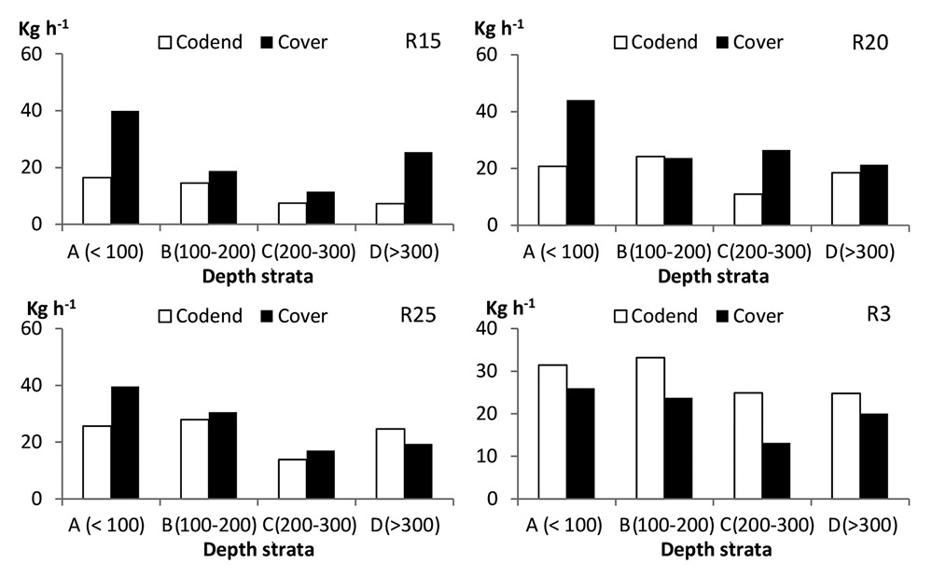 | Full size image

Fig. 3. – Mean yield (kg h⁻¹) for the total retained catch (codend) and escaped catch (cover) by depth and sorting grid.
The escape percentages for each type of grid against the tow duration and depth are given in Figure 4. As expected, escape percentages decreased with increasing grid spacing, but the effects of tow duration and depth differed between grids. While the interaction between depth and tow duration (two-way ANOVA) was not significant for any grid (p>0.05), depth was a significant factor for the 15- and 25-mm sorting grids (p<0.05) and tow duration was significant (p=0.024) only for the 20-mm sorting grid.
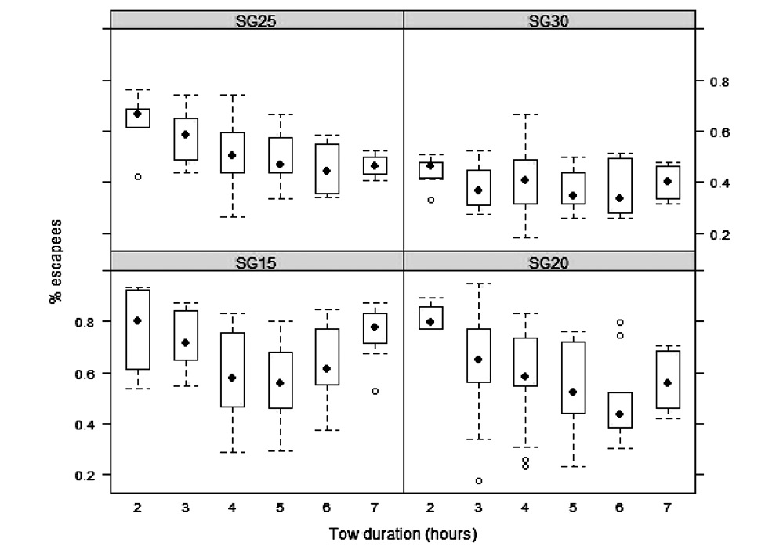 | Full size image

Fig. 4. – Percentage of escaped individuals and tow durations for each sorting grid (SG 15 SG 20, SG 25 and SG 30 corresponding to 15-, 20-, 25- and, 30-mm bar spacing, respectively).
The percentages of escaped (cover) and retained (codend) biomass for 3 crustacean, 4 fish and 3 cephalopod species are given in Figure 5. As the space between the bars increases, so does the percentage of retained biomass of deep-water rose shrimp (76%-92%), prawn (23%-86%), and Norway lobster (14%-91%) (Fig. 5A,C).
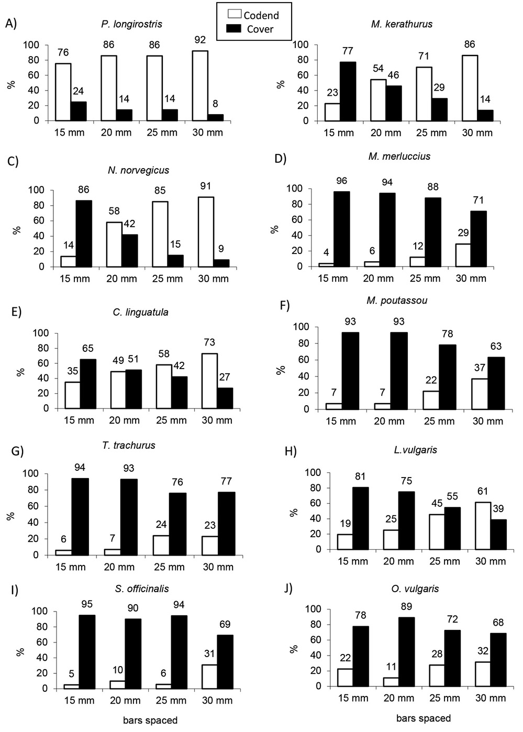 | Full size image

Fig. 5. – Percentage of biomass caught in the cover and in the codend by grid for the target and some by-catch species.
For the commercial by-catch species under analysis, the sorting grids permitted a significant escape percentage among finfish species: 96%-71% for hake, 65%-27% for spotted flounder, 93%-63% for blue whiting and 94%-77% for Atlantic horse mackerel (Fig. 5D,G). The same tendency is observed for cephalopod species: 81%-39% for squid as the spacing between the bars increased, 95%-69% for cuttlefish and 78%-68% for octopus (Fig. 5H,J).
At first sight, the grid with 30 mm between the bars is the one that achieves the highest catch percentage for the crustaceans, with an average of 60% less finfish and cephalopods retained in the codend, so it is the one that best achieves the sorting objectives of the device (Fig. 5A,J).
Target species
Length-frequency distributions for the crustacean species are given in Figure 6. For deep-water rose shrimp the size range varied from 10 to 40 mm CL (Fig. 6A,D). Significant differences were found between codend and cover size distributions, according to the K-S test (Table 4). However, selectivity parameters could not be estimated for this species due to lack of convergence, probably due to the lack of selectivity, with very similar size ranges for the codend and the cover for deep-water rose shrimp.
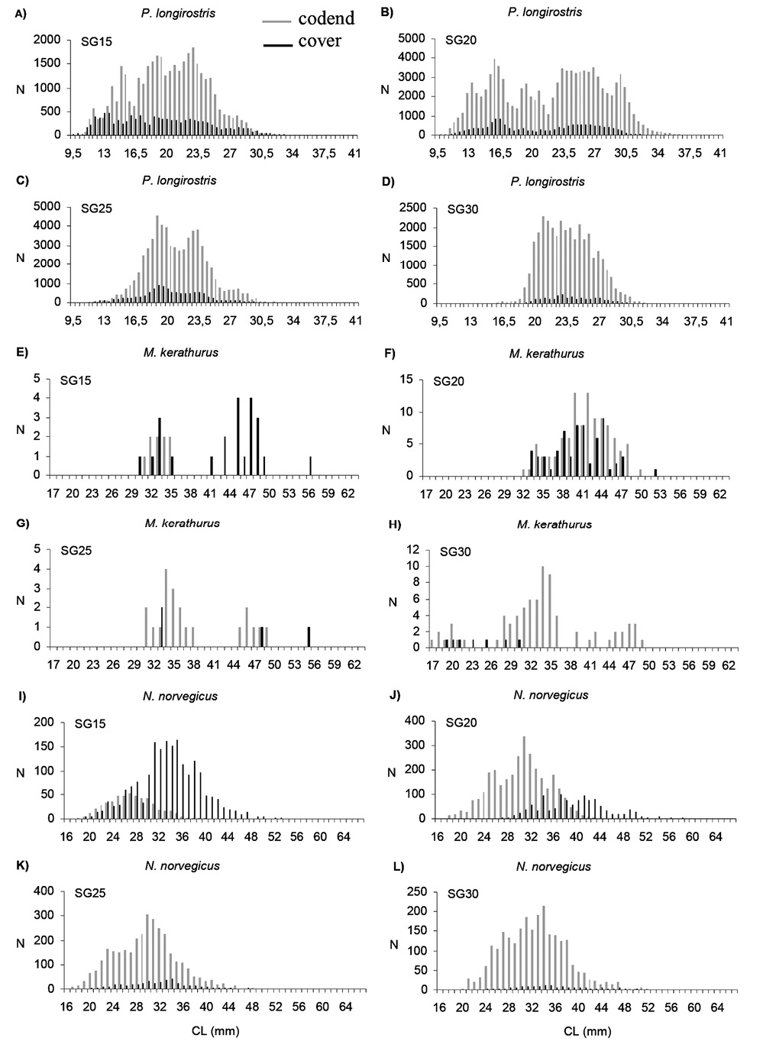 | Full size image

Fig. 6. – Cover and codend length distributions of P. longirostris (A-D for 15- to 30-mm bar spacing, respectively), M. kerathurus (E-F for 15- to 30-mm bar spacing, respectively), and N. norvegicus (G-L for 15- to 30-mm bar spacing, respectively).
Table 4. – Results of the Kolmogorov-Smirnov test (α=0.01; NS not significant) comparing cover and codend length-frequency distributions.
 | Bar spacing
Species | 15 mm | 20 mm | 25 mm | 30 mm
P. longirostris | α | α | α | α
M. kerathurus | α | α | α | α
N. norvegicus | α | α | α | α
C. linguatula | α | α | α | NS
M. merluccius | α | α | α | α
L. vulgaris | α | α | α | α
S. officinalis | NS | α | α | α
The same results were found for the caramote prawn. The size range varied from 17 to 63 mm CL (Fig. 6A,D), with significant differences between codend and cover distributions but selectivity parameters could not be estimated due to lack of convergence.
The size range of Norway lobster caught varied between 16 and 60 mm CL (Fig. 6I,L), with significantly different codend and cover distributions according to the K-S test (Table 4). It was possible to estimate selectivity parameters for the 15- and 20-mm grids but not for the 25- and 30-mm grids due to the low escapement percentages and overlapped cover and codend distributions (Fig. 7). The L₅₀ value for the 15-mm grid was 30.31 mm CL, while for the 20 mm grid L₅₀ it was 34.73 mm CL (Table 5). In both cases, individuals were retained above the legal MLS of 20 mm CL for Norway lobster in the Gulf of Cadiz (Spanish Royal Decree 560/1955 dated April 7, 1995 establishing minimum legal sizes for certain fished species). Compared with the 15-mm grid, the 20-mm grid increased the percentage of retained Norway lobster (Fig. 5C), without reaching the percentages caught with the 25- and 30-mm grids, for which there was relatively little escapement.
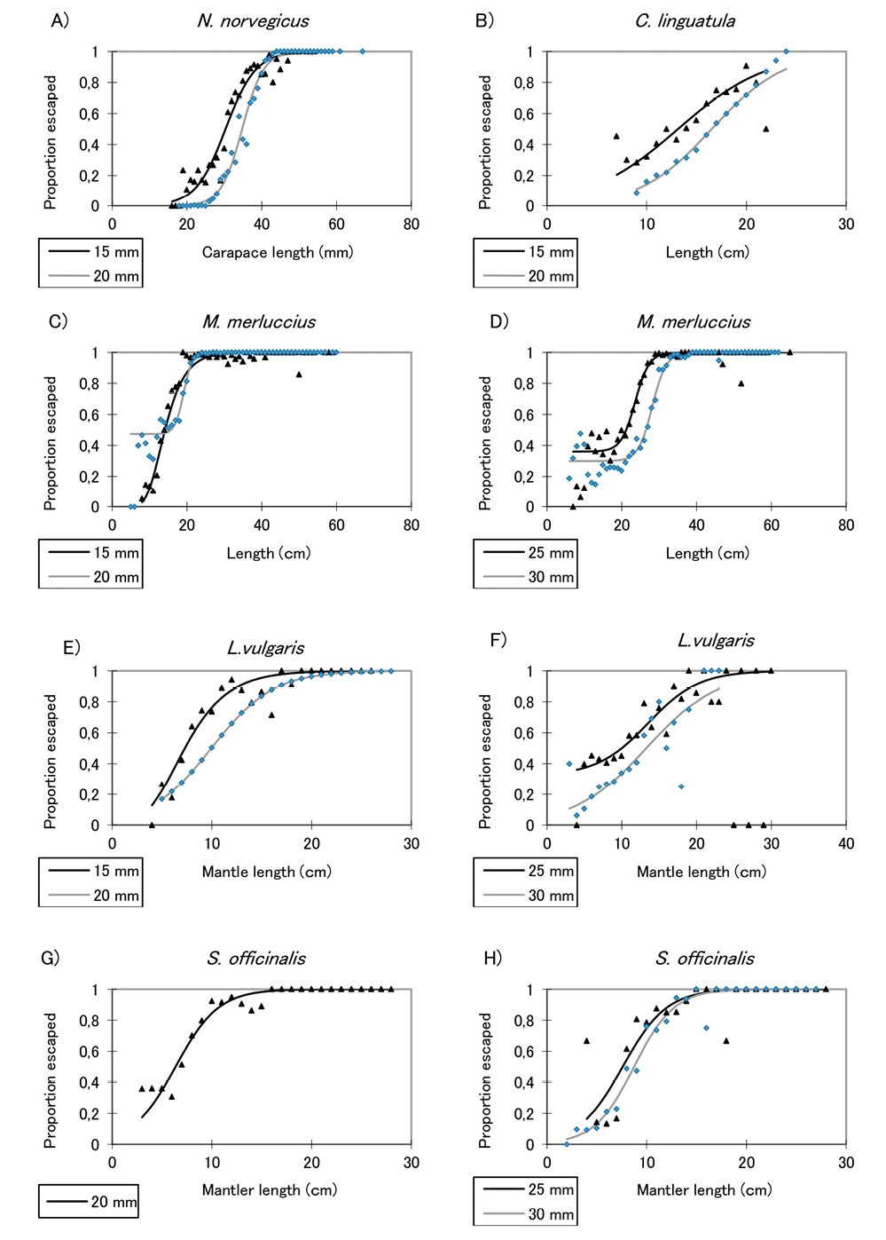 | Full size image

Fig. 7. – Selectivity curves for the main and by-catch species and for each bar spacing grid.
Table 5. – Escape selection curve parameters (a, b, δ and p), length of 50% escapement (L₅₀) in cm for fish species and cuttlefish and mm for N. novergicus, and selection range (SR) for the main commercial species for sorting grids with 15 and 20 mm bar spacing (SG15 and SG20, respectively). AIC, Akaike information criterion.
Species | Model | a | b | δ | p | L₅₀ | SR | AIC
SG15
 | Logistic | -7.54 | 0.25 |  |  | 30.31 | 8.83 | 86.510
N. norvegicus | Richard | -9.72 | 0.30 | 1.56 |  | 30.51 | 8.79 | 88.200
 | Encounter probability | -9.78 | 0.31 |  | 0.89 | 31.44 | 7.06 | 87,450
 | Logistic | -4.83 | 0.33 |  |  | 14.56 | 6.62 | 355.96
M. merluccius | Richard | -0.32 | 0.28 | 0.04 |  | 14.27 | 5.78 | 300.30
 | Encounter probability | -4.83 | 0.33 |  | 1.00 | 14.56 | 6.62 | 357.96
 | Logistic | -2.90 | 0.22 |  |  | 13.14 | 9.95 | 147.96
C. linguatula | Richard | -5.35 | 0.30 | 2.21 |  | 13.30 | 10.30 | 147.16
 | Encounter probability | -4.14 | 0.28 |  | 0.89 | 14.87 | 7.89 | 146.26
 | Logistic | -2.84 | 0.40 |  |  | 7.160 | 5.56 | 96.580
L. vulgaris | Richard | 0.00 | 0.35 | 0.11 |  | 7.280 | 4.60 | 92.030
 | Encounter probability | -2.84 | 0.40 |  | 1.00 | 7.160 | 5.56 | 98.570
SG20
 | Logistic | -12.24 | 0.35 |  |  | 34.73 | 6.230 | 56.310
N. norvegicus | Richard | -7.68 | 0.26 | 0.33 |  | 34.35 | 6.680 | 59.101
 | Encounter probability | -12.24 | 0.35 |  | 1.00 | 34.73 | 6.230 | 58.310
 | Logistic | -3.96 | 0.29 |  |  | 13.46 | 7.470 | 575.72
M. merluccius | Richard | -28.33 | 1.27 | 15.22 |  | 13.91 | 13.09 | 251.66
 | Encounter probability | -16.69 | 0.87 |  | 0.53 | 19.11 | 2.250 | 241.58
 | Logistic | -4.55 | 0.28 |  |  | 16.53 | 7.983 | 112.33
C. linguatula | Richard | -7.28 | 0.38 | 1.91 |  | 16.68 | 7.702 | 109.45
 | Encounter probability | -5.31 | 0.31 |  | 0.94 | 17.05 | 7.054 | 111.08
 | Logistic | -3.22 | 0.32 |  |  | 9.952 | 6.780 | 84.830
L. vulgaris | Richard | -4.09 | 0.35 | 1.48 |  | 9.951 | 7.231 | 87.651
 | Encounter probability | -3.22 | 0.32 |  | 1.00 | 9.953 | 6.780 | 86.830
 | Logistic | -2.95 | 0.46 |  |  | 6.352 | 4.732 | 91.381
S. officinalis | Richard | 0.00 | 0.37 | 0.14 |  | 6.181 | 4.430 | 97.023
 | Encounter probability | -3.56 | 0.51 |  | 0.88 | 6.962 | 4.292 | 92.441
By-catch species
Hake from 7 to 60 cm, with modes between 11 and 15 cm TL depending on the bar spacing, were caught. According to the K-S test (Table 4), codend and cover size distributions were significantly different, showing that for this species the by-catch reduction device was highly size-selective. The sorting grids retained sizes between 7 and 29 cm TL, below the MLS for hake (although with low percentages, Fig. 5D), while allowing the larger sizes to escape. The estimated L₅₀ values were 14.27, 19.10, 23.58 and 28.17 cm for the 15, 20, 25 and 30 mm grids, respectively (Table 5 and 6).
Table 6. – Escape selection curve parameters (a. b. δ and p), length of 50% escapement (L₅₀) in cm for fish species and cuttlefish and mm for N. novergicus, and selection range (SR) for the main commercial species for sorting grids with 25- and 30-mm bar spacing (SG25 and SG30, respectively). AIC, Akaike information criterion.
Species | Model | a | b | δ | p | L₅₀ | SR | AIC
SG25
 | Logistic | -3.84 | 0.21 |  |  | 18.25 | 10.44 | 465.53
M. merluccius | Richard | -19.50 | 0.70 | 8.49 |  | 19.37 | 13.40 | 285.73
 | Encounter probability | -12.51 | 0.53 |  | 0.64 | 23.58 | 4.413 | 242.59
 | Logistic | -1.51 | 0.16 |  |  | 9.513 | 13.87 | 127.83
L. vulgaris | Richard | -1.83 | 0.16 | 1.21 |  | 9.551 | 14.39 | 129.37
 | Encounter probability | -3.96 | 0.29 |  | 0.68 | 13.51 | 7.482 | 123.25
 | Logistic | -3.43 | 0.45 |  |  | 7.590 | 4.860 | 65.040
S. officinalis | Richard | -1.76 | 0.40 | 0.35 |  | 7.574 | 4.421 | 66.210
 | Encounter probability | -3.43 | 0.45 |  | 1.00 | 7.592 | 4.860 | 67.052
SG30
 | Logistic | -1.98 | 0.09 |  |  | 23.19 | 25.70 | 1188.18
M. merluccius | Richard | -50.07 | 1.36 | 25.43 |  | 23.82 | 20.52 | 877.19
 | Encounter probability | -15.86 | 0.54 |  | 0.70 | 28.17 | 4.080 | 466.40
 | Logistic | -2.76 | 0.21 |  |  | 13.27 | 10.58 | 78.990
L. vulgaris | Richard | 0.00 | 0.15 | 0.19 |  | 13.06 | 11.35 | 75.933
 | Encounter probability | -2.75 | 0.20 |  | 1.00 | 13.27 | 10.58 | 80.992
 | Logistic | -4.41 | 0.50 |  |  | 8.740 | 4.362 | 67.240
S. officinalis | Richard | -4.49 | 0.51 | 1.01 |  | 8.771 | 4.301 | 69.281
 | Encounter probability | -4.88 | 0.55 |  | 0.97 | 8.900 | 4.011 | 68.591
For spotted flounder, size distributions of the codend and cover were significantly different for all sorting grids except for the 30-mm grid (Table 4). Selectivity estimates could only be estimated for the 15- and 20-mm grids, with estimates of L₅₀ of 14.87 and 16.68 cm TL, respectively (Table 5). The catch percentage increased with increasing bar spacing, ranging from 35% to 73% for the 15- and 30-mm grids, respectively (Fig. 5E). The size ranges of fish retained in the codend ranged from 7 to 25 cm TL, with modal values of 11 to 17 cm, depending on the grid bar spacing.
For squid, the size distributions in the codend and cover were all significantly different (Table 4). Selectivity curves were fitted (Fig. 7) with estimated L₅₀ values of 7.28, 9.95, 13.51 and 13.06 cm ML for the 15-, 20-, 25- and 30-mm sorting grids, respectively (Tables 5 and 6). The sizes ranged from 4 to 21 cm ML, with modal values between 6 and 11 cm ML, depending on the bar spacing. The catch percentage varied between 19% and 61% (Fig. 5H).
For cuttlefish, the size distributions showed a wide variation, from 3 to 16 cm ML, with a modal size of 7 cm ML. According to the K-S test, cover and codend size distributions were significantly different for all grids except the 15-mm one (Table 4). The fitted selectivity curves for the 20-, 25- and 30-mm bar grids are shown in Figure 7. The estimated values of L₅₀ were 6.35, 7.59 and 8.74 cm ML, respectively (Tables 5 and 6). The catch percentages were low and they increased as the separation between the bars increased, ranging from 5% to 31% of retained cuttlefish for the 15- and 30-mm grids, respectively (Fig. 5I).
DISCUSSIONTop
The Gulf of Cadiz trawl fishery has a multispecies nature, with catch composition varying considerably with depth. There are, however, vessels targeting mostly deep-water rose shrimp throughout the year due to its high economic value in this area.
Encouraging results for the target crustacean species were obtained with the sorting grid device used for the first time in the Gulf of Cadiz. In particular, the 30-mm grid showed high retention percentages, reducing the on-board sorting time and significantly improved the quality of the catches of Norway lobster, deep-water rose shrimp and prawn, two of which are very fragile species, with less crushing and damaged taking place, thanks to the considerably reduced catch biomass in the codend.
As the modified Nordmøre grid is designed to reduce the by-catch of finfish by facilitating the escape of large fish, its efficiency as a finfish fishing gear is very low, with only small sized individuals being retained. These results are in agreement with those of Isaksen et al. (1992), who evaluated the use of a sorting grid with a 19-mm separation between bars to reduce the fish by-catch in a shrimp trawl fishery. Indeed, the use of this device is compulsory by law in the Norwegian trawling fleet since 1990-1992.
For Norway lobster, the grids with the smallest separation (15 and 20 mm) were the only ones with size selection. This finding could be due to the robust carapace and morphology of the species, which may prevent larger individuals from going through small bar spacing and allow them to escape towards the cover. The mean selection sizes (L₅₀) obtained were 30.31 and 34.73 mm CL for the 15- and 20-mm grids, respectively. However, escape percentages were high for the 15- and 20-mm sorting grids, varying between 86% and 42%, respectively, which makes them not the most appropriate for this fishery. On the other hand, 25- and 30-mm sorting grids had lower escape percentages of 15% and 9%, respectively, with a wide range of size captured.
European hake, regardless of bar spacing, had high escape percentages and consequently minimal codend catches. The maximum retention percentage (29% of the total catch) was observed with the 30-mm bar spacing. The L₅₀ estimates were 14.12, 19.1, 23.75 and 28.18 cm for the 15-, 20-, 25- and 30-mm grids. All of the sorting grids tested allowed capture of hakes under 27 cm TL (the MLS for this species in the Gulf of Cadiz) in the codend. However, this is not a serious problem since deep-water rose shrimp and Norway lobster are caught at depths where individuals of hake smaller than 27 cm are not found under normal circumstances in this area (Sobrino et al. 1993). Small European hake are found at depths of less than 100 m, moving towards greater depths (200-400 m) only after sexual maturity is achieved (Anonymous 2005). Nonetheless, since their catch rates are fairly low (Table 7), the use of these sorting grids, which considerably reduce the catch of other non-target species, is still recommended.
Table 7. – Total number and weight percentage of hake specimens below the minimum legal size (27 cm) during the survey.
Depth range (m) | Number | Weight percentage %
<100 | 10201 | 35.81
100-200 | 11852 | 45.61
200-300 | 4149 | 14.57
300-400 | 1677 | 5.89
400-500 | 360 | 1.26
500-600 | 224 | 0.79
>600 | 20 | 0.07
For spotted flounder, escape percentages appeared to be the same regardless of the bar spacing of the grids (Fig. 6). This could be related to the morphology of the species, with the flattened body facilitating passage through any bar spacing. Selectivity parameters could only be estimated for the 15- and 20-mm bar spacing grids with L₅₀ of 14.87 and 16.68 cm, respectively (Table 5). It is perhaps interesting from the fishermen’s point of view since this species does not have an MLS in the Gulf of Cadiz, and they would continue landing spotted flounder, which is a species of medium economic value
When choosing the ideal spacing between the bars of the grid, a compromise must be reached between reducing the catch of undersized demersal species and promoting the escape of non-target species, while retaining most of the commercially valuable crustacean species. Isaksen et al. (1992) obtained encouraging results for the shrimp fishery in Norway, where the 19 mm bar spacing only reduced shrimp catch by 5% compared with control hauls (with no sorting device) and achieved a reduction in the by-catch for several different species.
The results of this study show that the sorting grid with a 30-mm bar spacing is the most suitable for deployment on-board the commercial trawlers of the Gulf of Cadiz, since it will reduce the by-catch of the species under study by 59%, while only reducing the catches of prawn, deep-water rose shrimp and Norway lobster by 14%, 8% and 9%, respectively. These values could be acceptable for the fishing fleet if we also take into account the positive effects on product quality. Furthermore, unlike the other grids with narrower bar spacing, there was no significant difference in escapement with increasing tow duration and depth for the 30-mm grid.
According to the majority of authors (Campos and Fonseca 2003, Campos et al. 2003, Sardà et al. 2006), it is difficult to apply management methods in multispecies fisheries where catches consist of many commercial species. If such regulatory measures were taken in order to improve fishery management in the Gulf of Cadiz, it would be advisable to split the fishing licences and mitigation measures into two groups: one for the trawlers fishing for crustaceans in deeper waters using a sorting grid and a 55-mm mesh size, and a different one for boats mainly fishing for finfish and cephalopods, which would use a different device and have a bigger mesh size, as is recommended by the EU. In Sweden the use of a grid when trawling for Nephrops has been mandatory since 2004. This fishery is now a single-species fishery where Nephrops constitutes 94% of the landings (Valentinsson and Ulmestrand 2005).
In a multispecies fishery, with interest in keeping legally sized commercial fish species, it is likely that a short-term economic impact will follow, and some form of incentive may be required to implement effective measures. If fishers cannot be convinced of the medium and long-term conservation and economic benefits of more selective fishing, and be persuaded to voluntarily adopt new measures, then direct economic incentives would be required (Catchpole and Revill 2007). This type of approach, adopting different measures and agreements for each type of licence, could be acceptable to the commercial trawling fleet in the Gulf of Cadiz, reducing the overharvesting of demersal resources and contributing to a more sustainable multispecies fishery.
Considering the above, our proposal for this fishery would be to implement this device in the part of the fleet targeting crustaceans. Taking advantage of the current situation of the fleet, with severe reductions in the allowable catches of target species such as Nephrops norvegicus, high fuel costs and reductions in fishing hours, we propose that vessels using the device voluntarily be offered incentives and opportunities such as a larger share of the TAC, increased fishing times according to species distribution and availability and a minimum market price for the product. Furthermore, with the recent EU regulation regarding a ‘landing obligation’ for discards, attempts should be made, through collaboration with fishermen and skippers, to find solutions for the discards resulting from this fishery. Meetings with the fleet representatives will be necessary for the future success of implementation of this device.
ACKNOWLEDGEMENTSTop
The authors would like to thank the crews of the fishing vessels for their hard work and skills, as well as all of their colleagues at the Instituto Español de Oceanografía who took part in the survey.
REFERENCESTop
Anonymous. 2005. Estudio de los parámetros biológicos (crecimiento y reproducción) de diversas especies de interés pesquero en aguas del Golfo de Cádiz y Sur-Mediterráneo. Consejería de Agricultura y Pesca, Junta de Andalucía Inf. Cient.
Akaike H. 1974. A new look at the statistical model identification. IEEE Trans. Autom. Contr. AC-19: 716-722.
http://dx.doi.org/10.1109/TAC.1974.1100705
Broadhurst M. K. 2000. Modifications to reduce by-catch in prawn trawls: A review and framework for development. Rev. Fish. Biol. Fish. 10: 27-60.
http://dx.doi.org/10.1023/A:1008936820089
Campos A., Fonseca P. 2003. Selectivity of diamond and square mesh cod ends for horse mackerel (Trachurus trachurus), European hake (Merluccius merluccius) and axillary seabream (Pagellus acarne) in the shallow groundfish assemblage off the south west coast of Portugal. Sci. Mar. 67: 249-260.
http://dx.doi.org/10.3989/scimar.2003.67n2249
Campos A., Fonseca P., Erzini K. 2003. Size selectivity of diamond and square mesh cod ends for four by-catch species in the crustacean fishery off the Portuguese south coast. Fish. Res. 60: 79-97.
http://dx.doi.org/10.1016/S0165-7836(02)00061-9
Catchpole T.L, Revill A.S. 2007. Gear technology in Nephrops trawl fisheries. Rev. Fish. Biol. Fish. 18(1): 17-31.
http://dx.doi.org/10.1007/s11160-007-9061-y
Coll M., Carreras M., Cornax M.J., et al. 2014. Closer to reality: Reconstructing total removals in mixed fisheries from Southern Europe. Fish. Res. 154: 179-194.
http://dx.doi.org/10.1016/j.fishres.2014.01.013
Ercoli R., Izzo A., Salvini L., et al. 2001. Experiencias de selectividad en los copos de las redes de arrastre y desarrollo de dispositivos selectivos con grillas en la pesquería argentina. El Mar Argentino y sus recursos pesqueros. INIDEP Doc. Cient. 3: 121-478.
Fonseca P., Campos A., Larsen R.B., et al. 2005. Using a modified Nordmore grid for by-catch reduction in the Portuguese crustacean trawl fishery. Fish. Res. 71: 223-239.
http://dx.doi.org/10.1016/j.fishres.2004.08.018
González-Garcés A., Pereiro F.J. 1994. Present stage of knowledge of hake populations which live on the continental shelf of the Atlantic and Mediterranean parts of the European Union, with especial attention to the Iberian Peninsula. Private publication. Instituto Español de Oceanografía. 327 pp.
Isaksen B. 1990. Grid sorting system to reduce by-catch of fish in shrimp trawl. ICES Fish. Tec. 8.
Isaksen B., Valdemarsen J.W., Larsen R.B., et al. 1992. Reduction of fish by-catch in shrimp trawl using a rigid separator grid in the aft belly. Fish. Res. 13: 335-352.
http://dx.doi.org/10.1016/0165-7836(92)90086-9
Jiménez M.P., Sobrino I., Ramos F. 2004. Objective methods for defining mixed-species trawl fisheries in Spanish water of the Gulf of Cádiz. Fish. Res. 67: 195-206.
http://dx.doi.org/10.1016/j.fishres.2003.09.048
Ramos F., Sobrino I., Jiménez M.P. 1997. Cartografiado temática de los caladeros de la flota de arrastre en el Golfo de Cádiz. Dirección general de investigación y formación agraria. Servicio de publicaciones y divulgación. Junta de Andalucía. 84-87564-96-8.
Sardà F., Bahamón N., Molí B., et al. 2006. The use of a square mesh codend and sorting grids to reduce catches of young fish and improve sustainability in a multispecies bottom crawl fishery in the Mediterranean. Sci. Mar. 70(3): 347-353.
http://dx.doi.org/10.3989/scimar.2006.70n3347
Sobrino I. 1998. Biología y pesca de la gamba blanca (Parapenaeus longirostris, Lucas 1846) en el Atlántico nororiental. Ph.D. thesis. Univ. Sevilla. Spain. 218 pp.
Sobrino I., García T. 2007. Reproductive aspects of the deep-water rose shrimp Parapenaeus longirostris (Lucas,1846) in the Gulf of Cadiz (southwestern Iberian Peninsula). Bol. Inst. Esp. Oceanogr. 23(1-4): 57-71.
Sobrino I., Jiménez M.P., Ramos F. 1993. Resultados preliminares sobre la distribución y abundancia de la merluza europea (Merluccius merluccius L.) en la región suratlántica española. En: González-Garcés A., Pereiro F.J. Estado actual de los conocimientos de las poblaciones de merluza que habitan la plataforma continental atlántica y mediterránea de la Unión Europea con especial atención a la Península Ibérica. Instituto Español de Oceanografía, Vigo, pp. 281-304.
Sobrino I., Jiménez M.P., Ramos F., et al. 1994. Descripción de las pesquerías demersales de la Región Suratlántica Española. Inf. Tec. Inst. Oceanog. 151.
Sobrino I., Ramos F., Jiménez M.P., et al. 1996. Study on the Spanish trawling fleet components and mapping of resources exploited by this fleet off the Gulf of Cadiz. Final Report. Cooperative Project No. IEO/EC-DG XIV/C/1/STUDY/94/029.
Tokai T. 1997. Maximum likelihood parameter estimates of a mesh selectivity logistic model through SOLVER on MS-Excel. Bull. Jpn. Soc. Fish. Oceanogr. 61 (3): 288-298.
Tokai T., Omoto S., Sato R., et al. 1996. A method of determining selectivity curve of separator grid. Fish. Res. 27: 51-60.
http://dx.doi.org/10.1016/0165-7836(95)00471-8
Valdermarsen J.W., Lehmann K., Riget F., et al. 1993. Grid devices to select shrimp size in trawls. ICES Stat. Meet. Fish. capt. Comm. CM 1993/B35.
Valentinsson D., Ulmestrand M. 2005. Mandatory use of species-selective grids in the Swedish Nephrops trawl fishery on national waters—Experiences after one year with new regulations. Inst. Mar. Res. Rep. Sweden, Lysekil.
Wileman D.A., Ferro R.S.T., Fonteyne R., et al. 1996 Manual of methods of measuring the selectivity of towed fishing gear. ICES Coop. Res. Rep. 215.
Copyright (c) 2015 Consejo Superior de Investigaciones Científicas (CSIC)
This work is licensed under a Creative Commons Attribution 3.0 Spain (CC-by).

Contact us scimar@icm.csic.es
Technical support soporte.tecnico.revistas@csic.es

