Sequence alignments

Spot 7714 (Hsp90 - HSP90B)

5 isoform-specific peptides confirmed by MS/MS

...R//TDDEVVQREEEAIQLDGLNAAQIK//D... (starts at position 53 of alignment A)
...R//LLSLTNEDAMASNEELTIK//I... (starts at position 144 of alignment A)
...K//YSQFINFPIYVWASK//T... (starts at position 299 of alignment A)
...K//DSDDPLAHIHFTAEGEVTFK//S... (starts at position 415 of alignment A)
...R//VFITDDFNDMMPK//Y... (starts at position 466 of alignment A)

Spot 3806 (Hsp70 – HSPA9)

11 isoform-specific peptides confirmed by MS/MS

...K//NAVVTVPAYFNDSQR//Q... (starts at position 258 of alignment B)
...R//VINEPTAAALAYGLDK//T... (starts at position 288 of alignment B)
...K//IIAVYDLGGGTFDISVLEIQK//G... (starts at position 311 of alignment B)
...K//AKCELSSSLQTDINLPYLTMDASGPK//H... (starts at position 387 of alignment B)
...R//SQFEGIVADLIR//R... (starts at position 421 of alignment B)
...K//VQQTVQDLFGR//A... (starts at position 467 of alignment B)
...K//SQVFSTAADGQTQVEIK//V... (starts at position 546 of alignment B)
...K//VLGQFTLVGIPPAPR//G... (starts at position 576 of alignment B)
...K//DRVEAVNMAEGIVHDTESK//M... (starts at position 655 of alignment B)
...K//QAATSLQQASLK//L... (starts at position 718 of alignment B)
...K//LFEMAYK//K... (starts at position 728 of alignment B)

Spot 4804 (Hsp70 – HSPA9)

4 isoform-specific peptides confirmed by MS/MS

...K//NAVVTVPAYFNDSQR//Q... (starts at position 258 of alignment B)
...R//VINEPTAAALAYGLDK//T... (starts at position 288 of alignment B)
...K//VQQTVQDLFGR//A... (starts at position 467 of alignment B)
...K//SQVFSTAADGQTQVEIK//V... (starts at position 546 of alignment B)

Spot 7508 (Hsp70 – HSPA8)

2 isoform-specific peptides confirmed by MS/MS

...K//SINPDEAVAYGAAVQAAIL[A>S]GDK//S... (starts at position 483 of alignment B)
...K//DNN[I>L]LGKFELTGIPPAPR//G... (starts at position 573 of alignment B)

Spot 8503 (Hsp70 – HSPA5)

3 isoform-specific peptides confirmed by MS/MS

...R//IEIESFFEGEDFSETLTR//A... (starts at position 399 of alignment B)
...K//DNHLLGTFDLTGIPPAPR//G... (starts at position 573 of alignment B)
...R//GVPQIEVTFEIDVNGILR//V... (starts at position 591 of alignment B)

Alignment A (Hsp90 family)
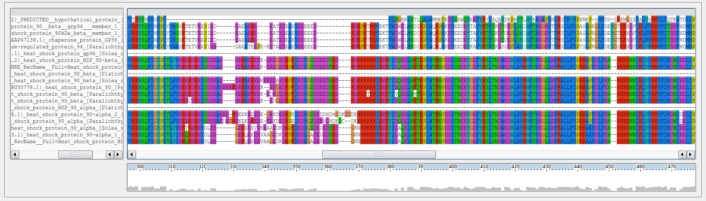
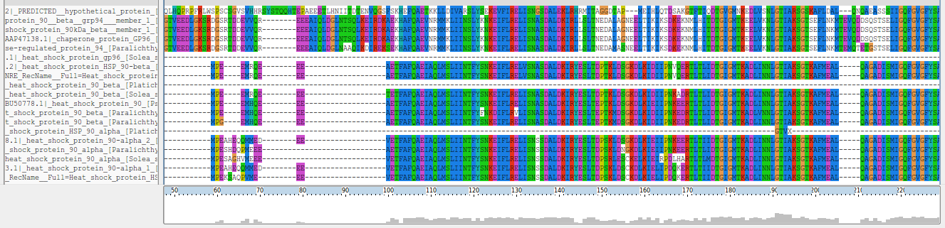
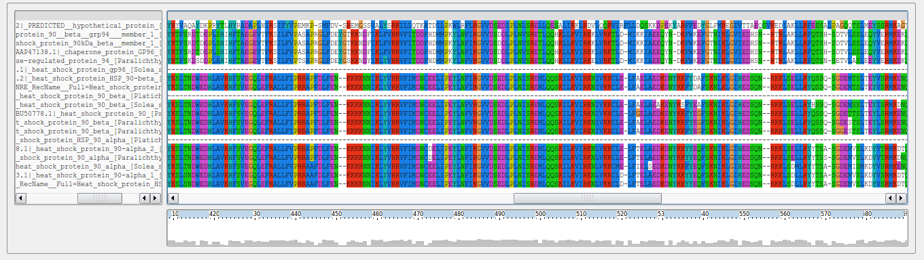

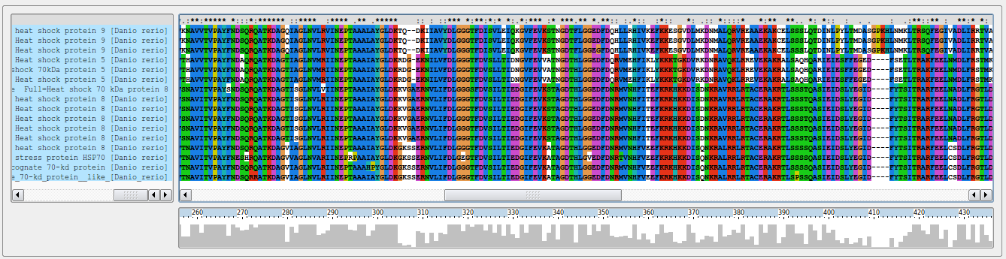
Alignment B (Hsp70 family)
