INTERVENTION FOR ORGANIZATIONAL INNOVATION – A CASE STUDY

Fernando Cardoso de Sousa
CIEO/University of the Algarve – cardoso_sousa@hotmail.com

Ileana Pardal Monteiro
CIEO/University of the Algarve – imontei@ualg.pt

João Pissarra
CIS/ISCTE – pissarra@sapo.pt

Abstract
This article is intended to report an intervention in a SME of the IT sector, aiming at an organizational change process towards a greater proactivity of employees. The presentation of the case includes the diagnosis, intervention, and the beginning of the implementation of innovation projects, based on an adapted model of third generation large-group organizational change methods.
In addition to the steps followed, small-world analysis techniques were used, with the intention of determining the existing communication networks; also, a content analysis of collected success stories was made, in order to suggest strong points for a future organizational culture.
The results clarified the desirable characteristics of an intervention method with large groups, adapted to Portuguese companies, and effective in organizational innovation project design. The analysis of the success stories helped to determine the strengths of an orientation for the future, while the use of measures of small-world networks allowed us to analyze the existing informal organization.
Although this study does not include the completion of the projects, due to difficulties in the company, it can provide a solid basis for application in future interventions.
Keywords - Organizational Change; Organizational Diagnosis; Large-Group Methods; Appreciative Inquiry; Small-World Networks

Introduction

Although, as stated by Kurt Lewin, just by trying to change an organization one can understand it, experts recognize (Burke, 2011) that the change is too complex to be approached by a single set of theories. Therefore, interventions with large groups, mainly developed by consultants, have been absorbing the full cycle of organizational change (McLean, 2006).
The lewinian tradition of the thirties, which came from German Gestalt, complemented with Von Bertalanfly’s systems theory and Alfred Bion’s psychoanalytic theory, inspired several social scientists who, in turn, contributed to the creation of several intervention methods with large groups, such as Future Search, with Weisbord and Janoff (2010), Search Conference, with Emery and Purser (1996), and Appreciative Inquiry, with Cooperrider and Whitney (2005).
These methods are distributed among the organizational change theories of second and third generations, Appreciative Inquiry being generally connoted with the last (Seo, Putnam & Bartunek, 2004). Although an evolution is indicated from the first generation, in the 40s (eg. action-research, sensory training, team building, socio-technical systems, and the famous T-Groups, of Kurt Lewin), to the second generation (eg. organizational transformation and interventions with large groups) and, finally, the third generation, in the '80s, summarized by Peter Senge’s learning organizations, and Appreciative Inquiry, several authors agree (Beer & Walton, 1994 ; Worley, Mohrman & Nevitt, 2011) that there has not been any marked improvement in the intervention methods, since each approach has continued its own way. The same happens with organizational diagnosis, a form on intervention on its own, where Howard and Associates (1994) report that there are no precise rules on the most appropriate sequence or model to follow, as well as in the evaluation of results.
And it was precisely because the complexity of systems and the theoretical limitations to field intervention that the authors have made an attempt to summarize the most important principles of the various forms of intervention in their own approach. Thus, this case study is no more than a stage in the development of an intervention method with large groups, complemented with the inherent diagnostic steps and the evaluation of results.

Large-Group Methods

Research on large-group methods, intended to bring innovation and change to organizations and communities, through the involvement of people in the decision making process, is well-documented. Kurt Lewin, Douglas McGregor, Mary Parker Follet, Fred Emery, Eric Trist, are just a few considered by Weisbord (2012) in an extensive review about the theoretical foundations of large-group methods, also described by Bunker and Alban (1997; 2006).
Large-group methods are tailored to suit group interventions with between 30 and 150 participants (ideally 70-80), meeting in sessions ranging from one to four days. Although large-group methods may deal with similar types of objectives, each has its own sequence of procedures. In general, sessions begin by asking the groups of eight (around tables of approximately 1,5m in diameter) for a vision of the desirable future, followed by a present diagnosis. This is made to understand the history of the organization and to create the necessary tension in attaining the ideal future. The definition of its strategic directions and required actions and timelines, together with follow-up procedures, generally close the sessions.
Given the involvement of all stakeholders in the same location at the same time, large-group methods allow for a change to occur at a much quicker than normal pace. They also allow opportunities for conflict management by establishing a focus on common ground rather than on differences, and to promote a flat hierarchy (Garcia, 2007).
Future Search was adopted as a reference methodology, due to its suitability for group decision making, its extensive description in the literature (Weisbord & Janoff, 1995; 2007; 2010), and the authors’ previous experience. The method brings together 60 - 70 participants for a period of 16 hours, over three days. On the first day, the first two and half hours are dedicated to defining the milestones of the history of the organization. At this point, the various types of stakeholders gather around mixed tables with stakeholders coming from different fields and experiences. This is because homogeneous groups have more difficulty in building a comprehensive picture. On the morning of the second day, participants work around tables by stakeholders, i.e., belonging to similar fields, gaining the homogeneity necessary for the construction of common scenarios. Time is devoted to the analysis of the present and future trends. The afternoon is dedicated to defining the future in terms of the "common ground" and a plan of action is determined on the morning of the third day. Common themes are confirmed and each one is clarified in terms of policies, programs, procedures and projects, which may include short and long term plans and the identification of the role players who will execute these within the time frames.
The other method taken as a reference was Appreciative Inquiry, with a similar design to Future Search, but lasting up to four days, with no limit to the number of participants, who develop the work into four phases: discovery (interviews and stories emphasizing the strong points), dream (building the desired future), design (system changes to meet the desired changes) and delivery (drawing up plans to implement the changes). Cooperrider and Whitney (2005), were based on the principle of Peter Drucker, who says that the main task of organizational leadership is to create a force alignment that makes irrelevant the weaknesses of the organization. Therefore, much of the action takes place around interviews conducted by the participants themselves, who seek to bring out images of the future, based on success stories of the past of the organization. So, for four days, participants designated by the planning committee as representing the "complete system" in the same room (can be several hundred people) define organizational culture through stories, which will represent the reality of the organization. Ludema, Whitney, Mohr and Griffin (2003) draw attention to the fact that the "whole system" in the room cause the participants the feeling of being part of a larger system, as well as the drawbacks of the approach based on problem solving, instead the examples of success, given that it makes people concentrate on the negative aspects of the organization. This principle, as many of the remaining ones, can be put to cause with attempts to gather scientific data to support it (Worley, Mohrman & Nevitt, 2011). That is why so many methods proliferate with a kind of “faith” beneath, instead of serious scientific considerations.

Adoption of a Small-Group Problem-Solving Method

Following on previous studies on problem solving procedures (Sousa, Monteiro, Walton & Pissarra, 2014), and its application in the higher education context (Sousa, Mendes & Monteiro, 2012), a four-step model was designed, comprising of Objective-Finding, Problem-Definition, Action-Planning, and the Action itself. The sequence of divergence (<) and convergence (>) is maintained only during the Objective-Finding and Problem-Definition steps, so that more options are available to choose from. In Objective-Finding a pre-consultation takes place with the manager in charge, so that the objective, group composition, and administrative requirements may be set. During Problem-Definition, the team enumerates all possible barriers to reach the objective, and then the manager selects a final problem definition to work with. During Action-Planning the team starts by listing all actions needed to achieve the goal and then puts them in order of execution. For each task, the “how to?” question is defined in such a way as to include any actions necessary to overcome the possibility of resistance. In coordination with the manager, each task is assigned to a sub-team, which defines deadlines and the entity responsible for evaluation of the output. The last step (Action) starts after the planning session.
This model focuses team members on implementation, using management control measures, communication and acceptance-related tasks. This approach provides an initial structure for the group, during the divergent phase of Problem-Definition, followed by an emotional linkage between members, as efforts are focused on reaching consensus during the convergent phase, so that the group may start working like a team. Another structuring step follows during Action-Planning, when team members’ creativity is expressed during the “how to?” development of each task in the plan. During the Action phase, the establishment of an effective communication structure within the team facilitates the collective awareness of what each team member is doing. Also, advertising the project within the organization reduces organizational resistance to task accomplishment and increases peer pressure for the team to comply with the project’s milestones and goals. A designated team leader, responsible before management for group coordination and project accomplishment, is very important.
This small-group problem-solving method was adapted to work with large groups in a study with higher education students, described in Sousa Monteiro and Pellissier (2015), aiming at bringing 62 participants, randomly arranged in ten groups, to solve the challenge consisting in the preparation of a single common essay, which would involve all students. The groups discussed the issue for an hour, resulting in a consensual problem: "What are the steps to take to structure the project, so that the physical constraints (eg difficulty in meeting.) Can be overcomed? ". The groups, after some time of discussion, identified five key tasks to solve the problem: (1) define the topics and subtopics; (2) establish the process of assigning the sub-themes to groups; (3) create a platform for virtual communication and establish personal meeting schedules; (5) list individual skills in each of the defined sub-themes. Then the students were asked to regroup into five groups, around each of the five identified tasks, according with personal preference, and asked to establish action plans to be implemented within one month.
At the end of the period (one month), all tasks were performed as planned and, about three months after, in a session held at the appointed day, almost all students attended the presentation, during which each component of the collective work was demonstrated.

Small-World Networks

Reviewing developments since Stanley Milgram came up with the designation of “small-worlds”, and the phenomenon of the “six degrees of separation”, necessary to link strangers in a network, Uzzi and Spiro (2005) define a small-world network as a structure that is both highly locally clustered and has a short path-length (i.e. the average number of steps that it takes all the actors in the network to reach each other). As explained by Kastelle and Steen (2010), empirically studying these connections implies a central role for social network analysis, where use is made of random-graph simulations or other statistical techniques that allow an understanding of the curvilinear relationship between some of the indexes of small-worlds and productivity or with innovation (too much communication takes working time), by the examination of dimensions such as path-length, density, geodesic distance, betweenness, and nbetweenness. Here path-length is the average number of steps that it takes for all of the actors in the network to reach each other; density represents the average existing percentage of ties over the total possible connections; geodesic distance represents the distances between nodes in the network, i.e., for each pair of nodes the shortest path can be determined; at network level, geodesic distance refers to the average number of paths between nodes; betweenness measures the subject’s position and the extent to which other people depend on him or her to access information or connect to other subjects; nbetweenness is the normalised betweenness, obtained by dividing simple betweenness by its maximum value, and represents the extent to which, on average, a node is connected to other nodes that are not connected to each other, expressed as a percentage.
The essence of a small-world structure is the linkage of locally intense clusters by occasionally bridging ties that provide the necessary tension between clustering and bridging, necessary for creative benefits. As Fleming and Marx (2006) explain, clustering alone may not be enough for creativity and may even be harmful due to the overabundance of connections, some of which may be redundant and favor insulation of groups from new information. Nevertheless, the cohesion of clusters, although harmful for ideation when the density of direct versus indirect ties is too large, may help the subsequent stages of development and diffusion of innovations (Ahuja, 2000). Direct ties refer to a connection between two nodes; indirect ties refer to the connection of two nodes via one or more nodes.
The clusters are bridged by people between them (the gatekeepers, or brokers) who, according to Burt (1992; 2004), have earlier access to a broader diversity of information and are central to translate that information across groups. These brokers may help ideas to travel between structural wholes (gaps of information flows), or clusters, and accumulate value in each one through a process of rediscovery and adaptation of the various constraints and requirements that may turn an idea into a valuable innovation for the organization (Ahuja, 2000).

“Quidgest” Case Study

To make the company diagnosis, thirty collaborators and two external stakeholders were interviewed, and a small-world network analysis was made in order to understand the informal organization. A content analysis of the collected success stories was made, in order to define the company’s perceived strong points.
Description and Diagnosis
Created in 1988, Quidgest is a Portuguese IT company, acting as a consultant and a developer of management software, which has grown up to near 100 coworkers in the last few years. The company is organized in a matrix structure, by projects together with specialized software departments.
The company was a pioneer in the computerization of the Portuguese Public Administration and, since 1992, it conceived an applications generator, called “GENIO”, a platform for rapid development of comprehensive information systems, combining model-based development with automatic code generation in different programming languages. Any employee can re-generate all the code for a project and get access to functional specifications (metadata). This ensures superior standards of agility and maintenance, increases the systems’ stability and allows the continuous monitoring of technological developments. Each new version, generated automatically, incorporates all the improvements in the technology layer, allowing to build programs in less time and with smaller and less specialized teams.
Quidgest promotes internships, expecting to attract coworkers able to maintain the quality and innovation levels. However, the trainee performs the tasks on real projects and the company cannot assign a mentor to accompany the evolution and to evaluate performance, thus harming the desired socialization.
The organization has no particular system of idea management, as it encourages everyone to propose ideas which, if feasible, are promptly adopted. This was repeatedly referred by the interviewees, who also mentioned the existence, sometimes, of too many individual initiatives.
The CEO agreed with this diagnosis and added that some coworkers are inhibited by difficulties and unable to transform them into challenges. Decision centralization is another management concern, aware of the need to strengthen the collective effort to improve efficiency and increase the employees’ performance, motivating them to adopt a more international approach and a permanent attention to the market trends.
In a contrasting view, some interviewees considered that there were an excessive centralization in management, although acknowledging a close relationship. Others, referred to the existence of something like a “complaint culture” fostered by some opinion leaders who focus only on negative aspects.

Small-World Diagnosis

The following analysis shows the existing small-world network at the time of the study. Data were collected by a questionnaire administered electronically to every company member, asking to signal each colleague with whom he or she had exchanged information for performance purposes a FEW TIMES (1) SOME TIMES (2) or OFTEN (3). The response rate was 100% and the answers were submitted to UCINET 6 program for analysis.

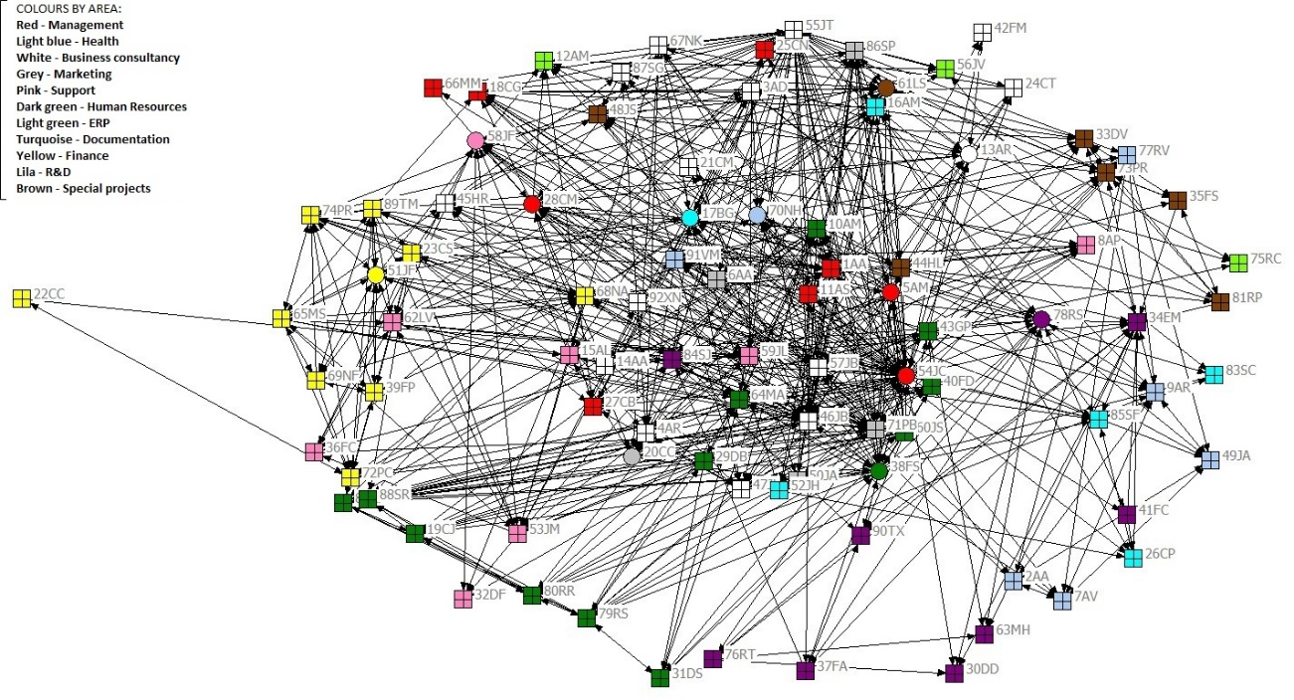

Figure 1. Density by working area. Area managers are indicated by a box.

As Figure 1 shows, the only consistent cluster appeared in the Finance Management area. Other visible clusters, although more dispersed, were Special Projects, and R&D. Human Resources Management showed two clusters, probably because there were two distinct roles in that area. All the other areas were more disseminated.
The level of betweenness centrality (the extent to which an actor falls on the paths between other pairs of actors in the network) is shown on Figure 2, in which the larger points refer to the individuals with a degree above 100, indicating they may assume the role of brokers in the communication network.

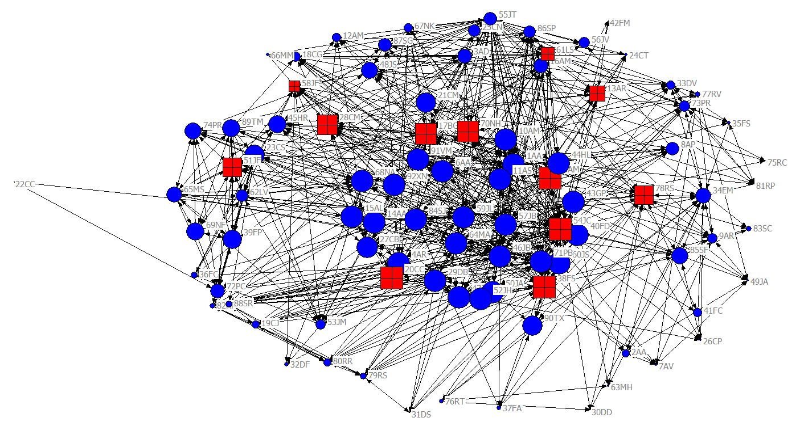
Figure 2. Graphic presentation of the level of betweenness centrality. Area managers are in boxes

The node 54JC is the CEO and 17BG, 38FS e 78RS are area managers. Number 54JC was connected with everyone else, as expected, and only surpassed by 27CB, responsible for salary management.; 17BG was located at the center of the network, but his area was dispersed; 38FS appears as a broker in her own area, alongside with 64MA, also a broker; 78RS was in the center of his area, communicating with the others through 84SJ, connected to the company’s networks.

Success Stories

The twenty-two success stories received were submitted to a content analysis, from which a strong client orientation emerged, as well as the effort to renew or create new products and the pride to work as a company team. Using the software T-Lab, version 8.2, the cognitive map associated to the word client was built, as Figure 3 illustrates. The distances refer to the frequency and proximity the different words are positioned in the original text, without any categorization or change. These distances measure the frequency each word had in the original text when associated with the word “client”. Thus, the words “new”, “form” and “business” indicate the coworkers’ concern in answering the clients’ challenges.

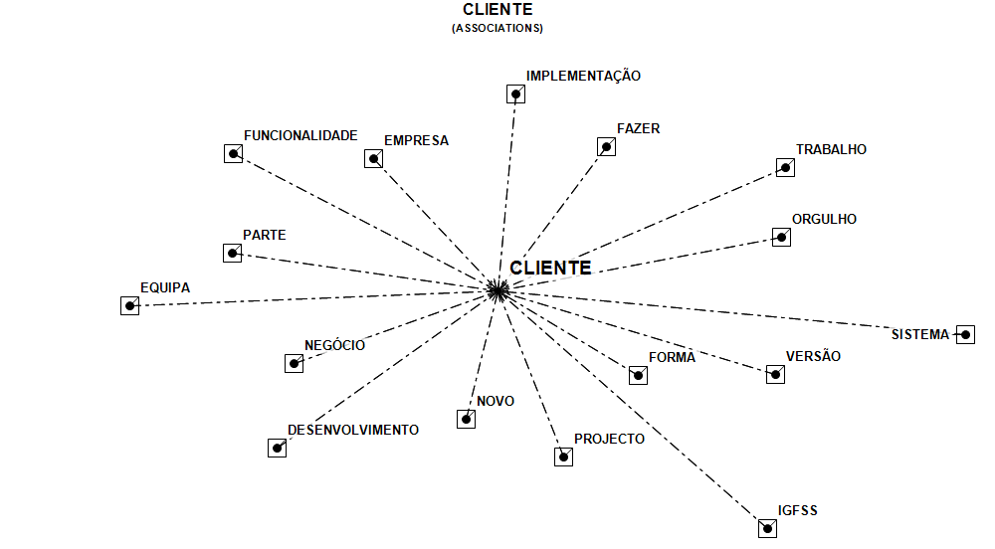
IMPLEMENTATION
TO MAKE
WORK
PRIDE
SYSTEM
VERSIONN
WAY
EUROPEAN FUNDS
PROJECTN
NEW
DEVELOPMENT
BUSINESS
CLIENT
TEAM
WORKABILITY
COMPANY
CLIENT
(associations)
Figure 3. Associative network of the word “client”
The keywords’ map, in the coworkers’ discourse reinforces the focus on the client and the high affective commitment drive to the projects and the search for new solutions or business opportunities.

Preparation, Intervention and Follow Up

The intervention preparation took the time needed for the diagnosis, and the negotiation with management of the several possible objectives, till the final one – to define the challenges and the actions needed to commit everyone in fighting the “common enemy”. A session was scheduled with all the company members and, a week before, an handout explaining the objective and the agenda of the meeting was issue to everyone. After that, management made sure all coworkers knew its content.
In the appointed day, about 80 participants (almost the whole company), randomly organized in 10 groups, took part in a four-hour session aimed at developing projects contributing to the designated objective. In the first hour and a half, the groups engaged in defining the most important challenges within the objective, followed by a selection of the CEO - What are the steps needed to increase people’s accountability? Then, teams were asked to list projects to match this challenge, producing a large number of possible projects, which were categorized in eleven, during the break. After the re-start, participants were asked to choose the project each one would like to develop, thus reorganizing in eight groups (three categories were left blank). The next sixty minutes were used to defining the action plan. Each group designated a facilitator for this second round.
The eight projects planned were: (1) organizational Structure – area coordination; (2) review of HR politics; (3) organizational Structure (outside area coordination); (4) professional consideration (rewards); (5) objectives, deadlines and priority management; (6) work methods; (7) competencies improvement to achieve objectives; (8) accountability for project delivery. Follow up meetings were scheduled and a general coordinator was designated, together with a communications team.
The first follow up session showed every team had run at least one face-to-face meeting to deepen up the action plan. Also, the communications team created a virtual platform were the team members could show their work. Due to the extension of some projects, it was necessary to negotiate their feasibility, and so the CEO met with each team facilitator to redefine each project output. However, since the distance between the imagined and the negotiated project was sometimes very large, the facilitator found real difficulties in making the team accept the changes.
After some time, the company was faced with new and urgent challenges, which led the groups to postpone the projects’ execution.

Discussion and Conclusions

Despite not having completed the cycle determined by the intervention, it became clear that the session mode of development was effective in creating organizational innovation projects in the company. Indeed, although many details must be changed, the intervention was a key stage in the work that the authors have developed and, more important, enabled the design of more effective interventions. The same happened with the measurements taken, i.e., those related to small-world networks, which was not possible to replicate but that was explicit enough to understand how the informal organization had established itself. Indeed, this first analysis was a good radiography of the company, and allowed for the identification of brokers in communication, facilitating the understanding of how organizational learning could be improved (Mascia, Magnusson & Björk, 2015), as well as innovation. As to success stories, its analysis confirmed the desirable future direction, coinciding with the intentions of management. Finally and although the projects have not yet been completed, many aspects influenced changes in the company, either resulting from the diagnosis, and from the session
If it were possible to repeat the entire process carried out in the company, we would have made the diagnosis the same way, either in the selection of interviewees or in the way to stay in tune with the concerns expressed by management. This approach (permanent link with management) was indeed the most salient aspect of the whole process, as recommended by several authors (Howard and Associates, 2009; Beer and Walton, 2009). This embodiment of the diagnosis, through which came out varied and contrasting views on the objectives set by management, was an important synthesis of information for management and for the preparation and monitoring of the intervention. The measures related to small-world networks and collection of success stories, seemed to be appropriate. Indeed, any data collection beyond what is perceived as important by management and employees, has no use for the kind of work that was needed.
However, there are aspects that should be modified, including some related with the session itself, and its previous preparation, such as:
• The operation of the organizing committee was not fully tested, since, having participated the entire company, it was not necessary to make a preliminary selection of participants and the organizational work was done directly by management, which also appointed a responsible for the logistics team.
• The duration of the session, although with the steps for the reduction of the time properly explained in previous articles (Sousa et al, 2012; 2014; 2015), was too short, requiring additional meetings to define action plans for the projects. In this case, the physical meeting of the teams was not very difficult, due to the location and type of activity of the company but, in other cases, this would have been more difficult. Thus, the duration session should be added to six hours, in order to allow for the complete construction of action plans.
• Taking into consideration all the pros and cons, we believe that the facilitators should be pre-appointed and trained to work during the session, thus forcing small changes in the session. The biggest advantage is the final feasibility of the projects, which led to a difficult negotiation with the teams.
• The project selection should not be left to management only, but to a small committee appointed by management. Indeed, management must decide on the fundamental aspects, but also should be far enough away from the definition of projects to leave freedom of decision to the teams. On the other hand, asking management to select only one problem/challenge, from the list provided by the teams, is clearly insufficient and should the extended every problem considered important and achievable by management.
Since the authors have had the opportunity to put into practice the suggested changes, with success, it is thought that future research should be directed towards improving efficiency in the training of facilitators, as well as in the ability to build a more thorough history of the organization, based in deeper interviews.
References

Ahuja, G. (2000). Collaboration networks, structural holes, and innovation: A longitudinal study. Administrative Science Quarterly. 45 (3): 425-455 .
Beer, M. e Walton A. (1994). Organization change and development. In: W. Burke, D. Lake, and D. Paine (eds.), Organization change: A comprehensive reader. John Wiley & Sons. San Francisco, CA. ISBN: 978-0-470-26056-2
Bunker, B. e Alban, B. (1997). Large-group interventions: Engaging the whole system for rapid change. San Francisco, CA: Jossey-Bass Publishers. ISBN: 0787903248.
Bunker, B. e Alban, B. (2006). The handbook of large group methods: Creating systemic change in organizations and communities. Jossey-Bass Publishers. San Francisco. ISBN: 978-0-7879-8143-3
Burke, W. (2011). Organization change: Theory and practice (edição original em 1935). Sage. London. ISBN: 978-1-4129-7886-6.
Burt, R. (1992). Structural Holes. Harvard University Press. Cambridge, MA. ISBN 9780674843714.
Burt, R. (2004). Structural holes and good ideas. American Journal of Sociology. 110 (2): 349-399.
Cooperrider, D. e Withney, D. (2005). Appreciative inquiry: A positive revolution in change. Berret-Koehler Publishers. San Francisco, CA. ISBN: 978-1576753569.
Emery, M. e Purser, R. (1996). The search conference: A powerful method for planning organizational change and community action. Jossey-Bass Publishers. San Francisco. ISBN: 978-0787901929
Fleming, L. e Marx, M. (2006). Managing creativity in small-worlds. California Management Review. 48 (4): 6-27.
Garcia, S.K. (2007). Developing social network propositions to explain large-group intervention theory and practice. Advances in Developing Human Resources. 9: 341-358.
Howard, A. e Associates (1994). Toward integrated organizational diagnosis. In: W. Burke, D. Lake, and D. Paine (eds.), Organization change: A comprehensive reader. John Wiley & Sons. San Francisco, CA. ISBN: 978-0-470-26056-2
Kastelle, T. e Steen, J. (2010). Are small-world networks always best for innovation? Innovation: Management, Policy & Practice. 12 (1): 75-87.
Ludema, J., Whitney, D. Mohr, B. e Griffin, T. (2003). The appreciative inquiry summit: A practitioner’s guide for leading large group change. Berret-Koehler Publishers. San Francisco, CA. ISBN-1576752488.
Mascia, D., Magnusson, M e Björk, J. (2015). The Role of Social Networks in Organizing Ideation, Creativity and Innovation: An Introduction. Creativity and Innovation Management. 24 (1): 102-108

McLean, G. (2006). Organization development: Principles, processes, performances. Berrett-Koehler Publishers. San Francisco, CA. ISBN: 978-1576753132
Seo, M., Putnam, L. e Bartunek, J. (2004). Dualities and tensions of planned organizational change. In M. Poole e A. Van de Ven (Eds.), Handbook of organizational change and innovation. London: Oxford University Press. ISBN: 13978-0-19-513500-8.
Sousa, F, Monteiro, I., Walton, A. e Pissarra, J. (2014). Adapting creative problem solving to an organizational context: A study of its effectiveness with a student population. Creativity and Innovation Management. 23 (2): 111-120.
Sousa, F., Mendes, F., e Monteiro, I. (2012). Criatividade, educação artística e resolução colaborativa de problemas: Um estudo de caso [Creativity, artistic education, and collaborative problem solving: A case study]. Revista Trama Interdisciplinar. 3 (1): 35-68.
Sousa, F., Monteiro, I., e Pellissier, R. (2015). Adapting large group methods to build small world networks in higher education, The Quality in Higher Education. 11: 66-87
Uzzi, B. e Spiro, J. (2005). Collaboration and creativity: The small-world problem. American Journal of Sociology. 111 (2): 447-504.
Weisbord, M. (2012). Productive workplaces: Dignity, meaning and community in the 21st Century, 3rd edition. Jossey-Bass Publishers. San Francisco, CA. ISBN: 978-0470900178.
Weisbord, M. e Janoff, S. (1995). Future search: An action guide to finding common ground in organizations & communities. Berrett-Koehler Publishers. San Francisco, CA. ISBN: 9781881052128
Weisbord, M. e Janoff, S. (2007). Don’t just do something, stand there: Ten principles for leading meetings that matter. Berrett-Koehler Publishers. San Francisco, CA. ISBN: 978-1-57675-425-2
Weisbord, M. e Janoff, S. (2010). Future search: Getting the whole system in the room for vision, commitment, and action, 3rd edition. Berrett-Koehler Publishers. San Francisco, CA. ISBN: 978-1-60509-428-1.
Worley, C., Mohrman, S. & Nevitt, J. (2011). Large Group Interventions: An Empirical Field Study of their Composition, Process, and Outcomes. The Journal of Applied Behavioral Science, 47 (4), 404-431

